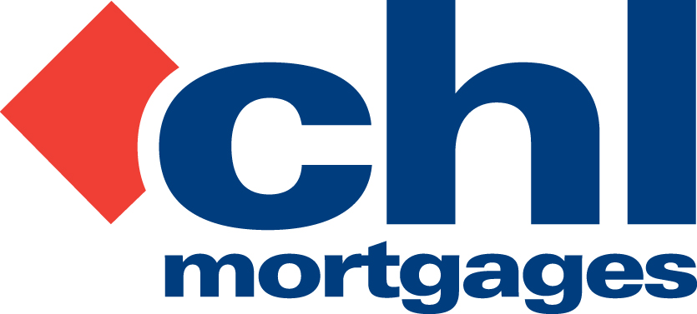

6 December 2011

PRESS RELEASE

16 CHL STAFF ACHIEVE DIPMAP QUALIFICATION

Specialist lender, CHL Mortgages, has today (6th December 2011) announced that 16 members of staff have achieved the new Diploma in Mortgage Advice and Practice (DipMAP).

The 16 employees come from a range of departments across the entire CHL Mortgages’ business and there was a 100% pass rate from those who took the qualification.

DipMAP is offered by the Institute of Financial Services and is a Level 4 qualification primarily designed for mortgage advisers who are seeking to go beyond the Level 3 qualification requirement. It is also open to those who do not work in an advice function but have already completed the Certificate in Mortgage Advice and Practice (CeMAP).

This achievement by staff at the lender follows on from CHL’s ongoing commitment to the Leadership and Management Programme, offered through the National Skills Academy for Financial Service (NSAFS). Earlier this year nine members of staff completed the course and more individuals are currently working their way through the qualification.

CHL offers its staff members access to a range of financial and management qualifications offered by a variety of learning institutions. CHL is committed to structured learning schemes for all employees as part of its commitment to continuous professional development and lifelong learning.

Bob Young, Managing Director at CHL Mortgages, commented

“Once again CHL staff members have shown their quality by completing the DipMAP qualification and securing their diplomas. To have a 100% pass rate is particularly special and goes to prove the dedication and competence of those involved. As a lender we continue to invest in our people and, in particular, their overall training and learning needs. We are not a business which likes to see employees standing still and we actively encourage all those within the business to set goals and work towards higher qualifications. As always we seek to provide all the support and time they need in order to help them through their course and ultimately their examinations. Having employees who regularly achieve these goals provides a real benefit to both them individually and the business as a whole. It is very pleasing to see these 16 members of staff securing a very significant, externally-validated exam and we are confident that they will now be even more competent in their roles due to their achievements.”

For full information on CHL visit: www.chlmortgages.co.uk

ENDS

For further information please contact:
Bob Young, Managing Director, CHL Mortgages
Tel: 01252 365890
Rob Griffiths, White Dragon Communications Ltd
Mobile: 07983 641566, E-mail: rob@whitedragoncomms.co.uk

NOTES TO EDITORS
About CHL Mortgages
- CHL Mortgages has been offering specialist mortgage solutions since 1992. It is based in Fleet, Hampshire and is part of the Irish Life & Permanent Group.
- CHL Mortgages is a pioneer of both buy-to-let mortgages and self-certification mortgage products for the self-employed. It has now grown to be a leading player in these sectors.
- CHL products are designed to meet the needs of various customers, ensuring CHL Mortgages lends responsibly and treats customers fairly.

CHL Mortgages
Admiral House, Harlington Way, Fleet, Hampshire GU51 4YA
Tel: 01252 812271
Fax: 01252 811826
Website: www.chlmortgages.co.uk

