PRESS RELEASE

5 July, 2010

ALDERMORE REACHES MORE DAs
VIA DISTRIBUTOR MORTGAGE CLUBS

Aldermore, the new intermediary residential and buy to let mortgage lender, has extended its reach into the directly authorised broker market, by making its products available to all DAs via its distribution partners’ mortgage clubs.

With immediate effect, all directly authorised brokers can access Aldermore’s full product range via the following clubs: 3mc, BDS Mortgage Club, L&G Mortgage Club, Mortgagebox (PTFS Mortgage Club), Mortgage Intelligence Mortgage Club, Mortgage Next Mortgage Club, Pink Mortgage Club, Platinum Options and PMS. Brokers must register with Aldermore before submitting applications and this can be done via its website: www.aldermore-mortgages.co.uk

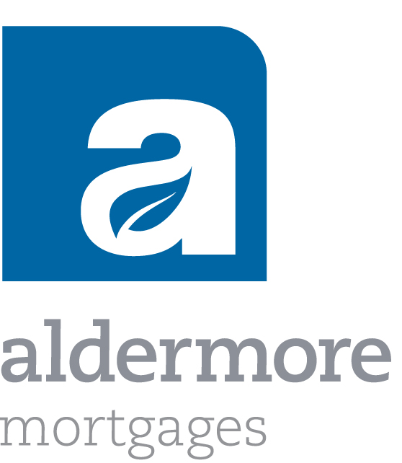
Colin Snowdon, Chief Executive, Residential Mortgages at Aldermore, said: “We’re delighted that directly authorised mortgage brokers now have an even wider choice of ways in which to access our product range. Brokers will discover that it takes just a few minutes to submit a clients’ case online and receive an immediate decision in principle. Brokers can also upload supporting documentation online, meaning they can retain their original files, and a DIP will leave only a soft footprint on their clients’ credit records.”

In the residential market, Aldermore has products for both house purchase and remortgaging, up to 80% loan to value with a choice of two year discounts starting from 3.98% and three and five year fixed rates starting from 4.93%.

In the buy to let market, mortgages are available up to 75% loan to value for the purchase or remortgage of a single property, with a choice of two year discounts starting from 4.98% and three and five year fixed rates starting from 5.78%.

Aldermore is planning to launch an additional range of limited edition mortgage products in the near future.

Intermediaries can obtain further product information at www.aldermore-mortgages.co.uk, by phoning 0333 321 1000 or by e-mailing: mortgage.sales@aldermore.co.uk

**ends**

For further information, journalists can contact:
Josh Cooper, PR Consultant Office: 01295 688243
josh@cooper-consultants.co.uk Mobile: 07768 355265

Notes to Editors

About Aldermore

Aldermore is a new name in British banking and is one of the most strongly capitalised banks in the UK.

With backing provided by AnaCap Financial Partners LLP and Morgan Stanley Alternative Investment Partners, Morgan Stanley's Private Equity Fund of Funds business, Aldermore raises deposits from consumers and lends to homeowners and small and medium sized businesses.

Aldermore does not depend on the wholesale, securitisation or international capital markets and has not been involved in any banking activities or the marketing of any exotic products which have been the cause of problems for so many financial institutions.

As a British bank, Aldermore is regulated by the Financial Services Authority and is registered under the Financial Services Compensation Scheme, which means customers’ savings are protected up to the statutory limit of £50,000 per person. Aldermore is also a member of the Council of Mortgage Lenders.

Aldermore markets its residential and buy to let mortgages via professional financial advisers located throughout England and Wales and all mortgages are underwritten and administered from an office in Wilmslow, Cheshire.

Aldermore also markets a range of commercial mortgages via specialist commercial finance brokers located throughout England and Wales. Commercial mortgages are underwritten and administered via Aldermore’s head office in Peterborough.

About AnaCap Financial Partners LLP

Established in 2005, AnaCap is a specialist private equity firm focused on making investments in the financial services sector across Europe.

AnaCap and its affiliated funds have raised more than £827 million of committed capital from highly regarded global institutional investors including Adams Street Partners, Goldman Sachs, Honeywell, Morgan Stanley Alternative Investment Partners and Allianz.

AnaCap’s portfolio in the UK includes Syscap, Conduit Capital Markets and Apex Credit Management. Cattles Invoice Finance was acquired in August 2009, which was subsequently rebranded Absolute Invoice Finance and sold to Aldermore in November 2009.

AnaCap also owns Credoma, a residential mortgage company based in the Czech Republic and Mediterranean Bank Plc which is based in Malta. In December 2009 AnaCap announced its intention to acquire Banco Popolare Ceská Republika, the Czech subsidiary of Italy's Banco Popolare, subject to confirmatory due diligence and all regulatory approvals.

