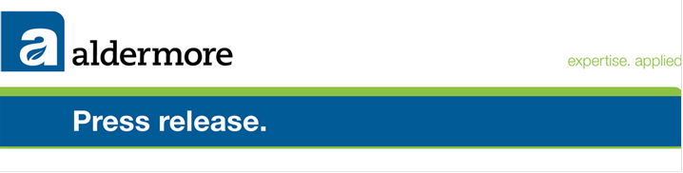
31 July 2013
Aldermore Financial Results for the Half Year Ending 30 June 2013
Highlights:
- Operating profit increases to £9.2 million
- Lending increased by over 34% on same period last year
- Balance sheet expanded by 26% to £3.19 billion
- Aldermore Chairman Sir David Arculus to step down from Board

Aldermore Bank has today published its interim financial results for the half year ending 30 June. The results show strong performance across the business in all key metrics, including the rapid expansion in gross lending, up 34% year-on-year to £2.7 billion, as Aldermore continues to position itself as a champion of British SMEs and homeowners in the UK.

The Bank, which became profitable for the first time in the last financial year, has reported an increase in operating profit, rising from £1 million as at the end of last year to £9.2 million as at the end of June.

A number of significant milestones were reached over the first half of this year, including the Bank’s balance sheet passing the £3 billion mark for the first time, rising to £3.19 billion, an increase of 53% year-on-year. Retail deposits are up by nearly 30% on the year to £2.26 billion.

Data released by the Bank of England on the Funding for Lending Scheme (FLS) for Q1 2013 continues to demonstrate Aldermore’s significant contribution to supporting households and SMEs across the UK. Aldermore’s Q1 2013 net lending figure through the FLS of £230 million was the sixth highest amongst all scheme participants.

Aldermore has undertaken significant additional investment in its operations and infrastructure in this period, with headcount across the Bank up almost a quarter compared to this time last year to 629 people across the country. As a Bank with no legacy issues or branch network, Aldermore has continued to invest in its technology and platform to take advantage of its market-leading position in providing exceptional customer service online. It is possible to open an account online and be able to deposit funds in less than 15 minutes.

Phillip Monks, CEO, commented:
“Our results truly speak for themselves and demonstrate the rapid growth we are seeing across all areas of the Bank. We are firmly in the black, recording a pre-tax operating profit of £9.2 million, significantly ahead of what we’ve achieved in previous years. We have remained focused on building a thoroughly modern and innovative Bank and we are now seeing the fruits of our labour pay off. I strongly believe our banking model, offering great rates to British Savers and lending to British SMEs and households is working. Our customers give us honest feedback via our website and they continue to tell us Aldermore is ‘banking as it should be’.”

“We plan to continue our support of SMEs and homeowners by further increasing our lending over the remainder of this year, which we feel is particularly important at a time when many are finding it difficult to gain access to finance from many of the high-street banks. We are very much on track to meet our targets for this year and deliver exceptional service for our customers across the UK.”

Aldermore Chairman to step down from Board

In light of these exceptional results, Aldermore’s Chairman Sir David Arculus has announced that he is to step down from the Board. He will be replaced on an interim basis by existing Non-Executive Director John Callender, who takes-up the post this morning.

Sir David has decided the time is right to hand over to a new Chairman to drive the next phase of the Bank’s development and growth. The search for a successor is already underway and Sir David is playing a key role in that process.

Speaking on his resignation Sir David Arculus said: “Aldermore has grown considerably in the last four years and become known as a strong challenger Bank that has consistently lent to British SMEs and homeowners throughout the financial crisis. I am proud to have been part of this exciting journey but feel it’s the right time for me to step down and hand over the reins as Aldermore moves to the next stage of its development. I will be assisting Aldermore in their search for my replacement and have no doubt Aldermore will continue to go from strength to strength.”

Commenting on Sir David’s departure, Phillip Monks, Aldermore CEO, said: “Sir David has done a remarkable job helping us get to where we are today. Aldermore has seen unrivalled growth over the last four years and I am personally grateful for his mentorship and perspective. We wish him all the very best and look forward to the appointment of a new Chairman who will help us continue to grow and deliver for our customers.”

Full details of the results can be found on our website here.

For further information journalists can contact:
Mike Robb, Nicola York or Adam Taylor at Cicero on 020 7665 9544 or aldermoreteam@cicero-group.com
Adam Taylor
Associate
Cicero Group
+44 (0)20 7297 5971
+44 (0)7557 965 958
www.cicero-group.com

