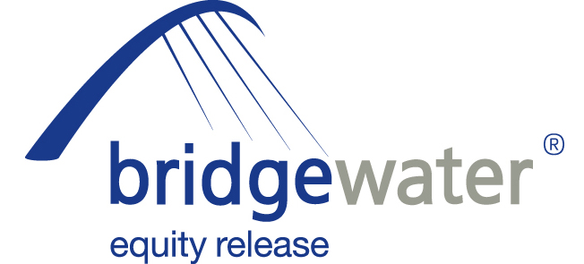

23 February 2012

BRIDGEWATER ANNOUNCES FURTHER STATE
BENEFITS UPDATE SEMINAR

Bridgewater Equity Release, the home reversion specialist, has today (23rd February 2012) revealed the date of its latest State Benefits Update seminar for advisers, in association with Ferret Information Systems.

The free event will be held at the offices of Ashfords LLP, Grenadier Road, Exeter on Wednesday 7th March from 10:30am to 1pm.

The seminar, which follows on from successful events in Warrington and London in November last year, is designed specifically for advisers working with equity release and was formulated as a direct response to intermediaries requesting more direction from providers on the impact of equity release on State Benefits.

Gareth Morgan, Managing Director of Ferret Information Systems Ltd, will lead the seminar which will explore the likely effect of welfare reforms on older people, how benefits will alter for homeowners and what impact the simplifications will have.

Peter Welch, Head of Sales & Distribution at Bridgewater Equity Release, will also run a short session on obtaining equity release leads from professional introducers.

Welch commented:

“Making sure equity release advisers are as educated and informed as possible when it comes to state benefit changes is of vital importance for both their own benefit and for the protection and satisfaction of their clients. Equity release can be a sensitive topic at the best of times and advisers have to tread particularly carefully when it comes to explaining the potential ramifications of benefit amendments. The expertise of Ferret Information Systems in developing the modelling of the future benefits system and the experience Bridgewater has in dealing with older homeowners will make this a particularly useful session for all advisers attending. We had very positive feedback from advisers attending our London and Warrington seminars at the end of 2011 and this latest event reaffirms our commitment to helping brokers make sense of these developments. In addition to the Exeter seminar, we also hope to be able to announce a further seminar date in the Midlands imminently.”

Free parking is available at the venue, lunch will be provided and certificates of attendance will also be made available to attendees.

Places are strictly limited, so advisers interested in attending should contact Karen McCulloch as soon as possible – 0191-269 5980 or kmcculloch@graingerplc.co.uk

ENDS

For further information please contact:
Peter Welch, Head of Sales and Distribution, Bridgewater Equity Release, Mobile: 07824 412439
Kurt Mueller, External Affairs Manager, Grainger plc (parent company of Bridgewater Equity Release), Mobile: 07584 235088; kmueller@graingerplc.co.uk
Rob Griffiths, White Dragon Communications Ltd, Mobile: 07983 641566; rob@whitedragoncomms.co.uk
Barney McCarthy, White Dragon Communications Ltd, Mobile: 07872 956711;
barney@whitedragoncomms.co.uk

Notes to editors

- Bridgewater Equity Release Limited was founded in 1998 and is the UK’s leading provider of home reversion plans with over 4,000 home reversion customers.
- Bridgewater Equity Release Limited is an award-winning provider and a member of Safe Home Income Plans (SHIP), the company dedicated to the protection of plan holders and the promotion of safe home income and equity release plans. Bridgewater offers a range of plans which abide by the SHIP Code of Practice.
- It is committed to ensuring that all its customers are fully aware of the scheme they are entering into and have considered all alternatives.
- Bridgewater Equity Release is a subsidiary of Grainger plc, which was established in 1912.
- Bridgewater Equity Release is a registered trade mark of Grainger plc. All rights reserved.
- Grainger plc is the UK’s largest specialist residential property owner and manager traded on the London Stock Exchange. Grainger’s business activities in the UK and Germany cover ownership, trading, fund management, property management and development of residential property. Grainger is the leading provider of home reversions, an equity release product, through Bridgewater Equity Release. Grainger has approximately £2.1 billion of wholly-owned property assets, £2.8 billion of assets under management and manages approximately 26,400 properties in the UK and Germany.

Bridgewater Equity Release Ltd
Citygate, St James’ Boulevard
Newcastle upon Tyne
Tyne and Wear
NE1 4JE
Tel: 0191-242 4820
Fax: 0191-269 5974
E-mail: enquiries@bridgewaterequityrelease.co.uk

