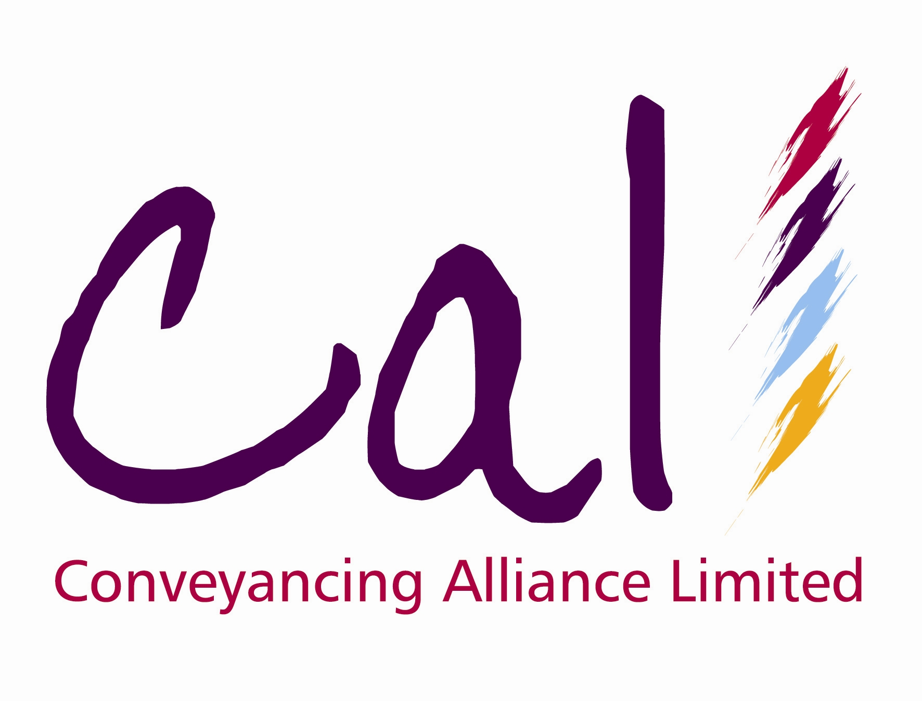
Press Release * Press Release
11 August 2008

CAL ANNOUNCE NEW APPOINTMENT

Conveyancing Alliance Ltd (CAL), the online conveyancing distributor, has today (11th August 2008) announced the appointment of Emma Pursey as its new Finance & Operations Manager.

Emma takes on responsibility for all CAL’s financial and office operations which includes broker-facing payment arrangements. She has previously been with CAL working on the business accounts and was recently responsible for the new system delivering a weekly payment run whereby brokers are paid their commission a week after completion.

Harpal Singh, Managing Director of CAL, commented:

“We are delighted to announce the appointment of Emma as CAL’s new Finance & Operations Manager. Emma already has vast experience within the CAL organisation having worked in the financial department for the last three years. Her new position will see her take on a much wider role within CAL focusing on areas such as payroll, HR, office management alongside all financial arrangements with our broker customers. This is an important new role within the CAL team and we are confident Emma will deliver real and ongoing value to the CAL proposition.”

Ends

For further information, please contact:
Harpal Singh, Managing Director, Conveyancing Alliance Ltd, E-mail: hsingh@movewithcal.co.uk
Rob Griffiths, White Dragon Communications Ltd, Tel: 01483 549282; Mobile: 07983 641566; rob@whitedragoncomms.co.uk

Notes to Editors

- An independent company, Conveyancing Alliance Limited (CAL), was created in 2004 as a business to business distributor of property conveyancing for the mortgage intermediary and property sales markets. In January 2008, a management buy-out of CAL took placed headed by managing director, Harpal Singh.
- CAL’s online portal enables intermediaries to transact with CAL’s national panel of solicitor firms through absolute system integration.
- CAL’s solicitors firms are carefully selected and monitored on their continued ability to demonstrate exceptional levels of service and highly competitive pricing.
- CAL’s conveyancing solutions give intermediaries a valuable income stream and an element of control over their clients’ legal property transaction, as well as an additional service offering to their clients. CAL offers intermediaries choice, value, control, service and simplicity.
- In 2007 CAL was recognised at the Mortgage Strategy Awards and the British Mortgage Awards.
- CAL also offers additional products to mortgage intermediaries and property sales professionals.

Conveyancing Alliance Ltd
12 Princess Way
Camberley
Surrey
GU15 3SP
Tel: 0845 077 0039

