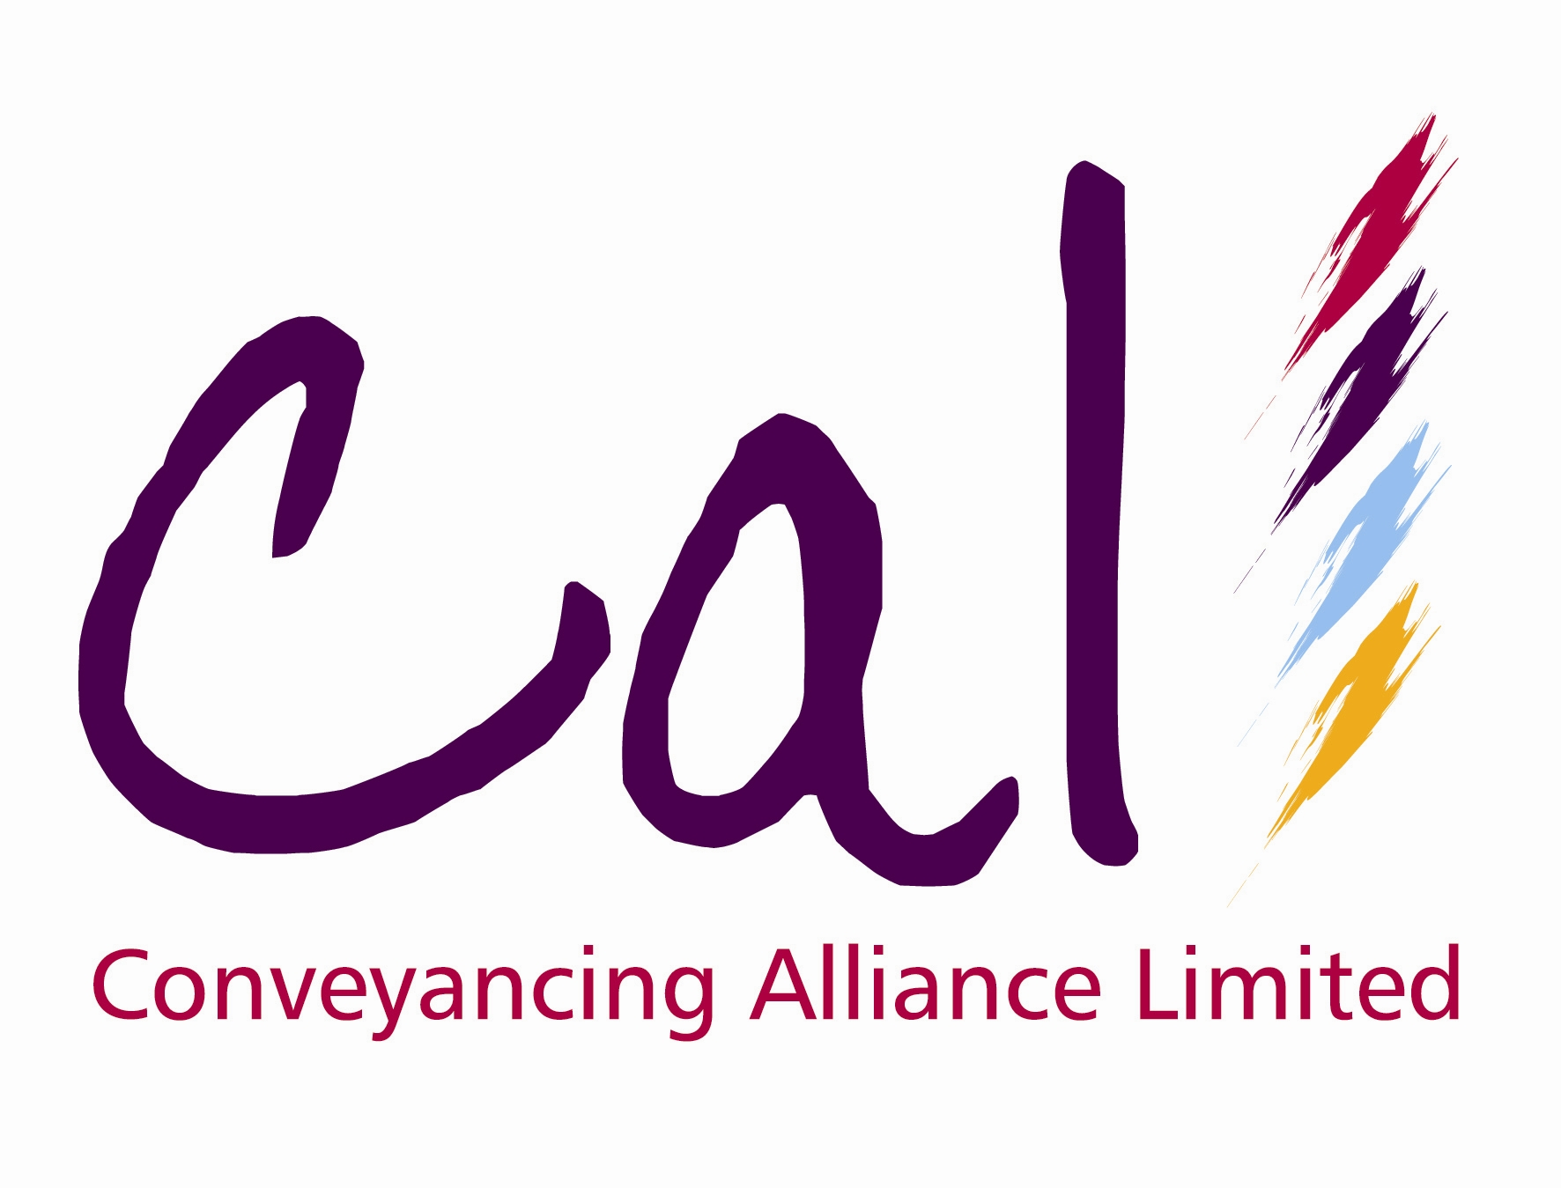
Press Release * Press Release
3 September 2008

CAL MAKES NEW ADDITION TO SOLICITOR PANEL

Conveyancing Alliance Ltd (CAL), the online conveyancing distributor, has today (3rd September 2008) announced the addition of Salans’ new satellite office in Thetford to its solicitor panel.

Salans’ Bromley-based office has been on CAL’s panel of solicitors for the past three years and the new office in Thetford, Norfolk has also been added. The Thetford office offers both residential conveyancing and volume legal processing to institutional clients.

The new Thetford office is headed up by Nigel Burgess. Brokers using CAL’s integrated online platform have already placed cases through to the new office via the case management system.

Harpal Singh, Managing Director of CAL, commented:

“CAL is delighted to add the new Salans office in Thetford to our panel of solicitors. We have been instructing Salans’ Bromley office for the past three years and I’m sure our broker customers will now be utilising the experience and service of those working in Thetford. We have strong relationships with all at Salans and our integration with the new office means brokers have further choice with regards to their conveyancing needs. We wish Salans much success and look forward to continuing this valuable relationship in the months and years ahead.”

Nigel Burgess, who heads up the Salans’ Thetford office, said:

“We are delighted that CAL has added the Salans’ Thetford office to its panel. We have a very positive and long standing relationship with CAL and we look forward to developing this partnership even further in the future.”

For more information on CAL, visit: www.movewithcal.co.uk

For more information on Salans, visit: www.salans.co.uk

Ends

For further information, please contact:
Harpal Singh, Managing Director, Conveyancing Alliance Ltd, Mobile: 07866 367844, E-mail: hsingh@movewithcal.co.uk
Rob Griffiths, White Dragon Communications Ltd, Tel: 01483 549282; rob@whitedragoncomms.co.uk

Notes to Editors

- An independent company, Conveyancing Alliance Limited (CAL), was created in 2004 as a business to business distributor of property conveyancing for the mortgage intermediary and property sales markets. In January 2008, a management buy-out of CAL took placed headed by managing director, Harpal Singh.
- CAL’s online portal enables intermediaries to transact with CAL’s national panel of solicitor firms through absolute system integration.
- CAL’s solicitors firms are carefully selected and monitored on their continued ability to demonstrate exceptional levels of service and highly competitive pricing.
- CAL’s conveyancing solutions give intermediaries a valuable income stream and an element of control over their clients’ legal property transaction, as well as an additional service offering to their clients. CAL offers intermediaries choice, value, control, service and simplicity.
- In 2007 CAL was recognised at the Mortgage Strategy Awards and the British Mortgage Awards.
- CAL also offers additional products to mortgage intermediaries and property sales professionals.

Conveyancing Alliance Ltd
12 Princess Way
Camberley
Surrey
GU15 3SP
Tel: 0845 077 0039
Website: www.movewithcal.co.uk

