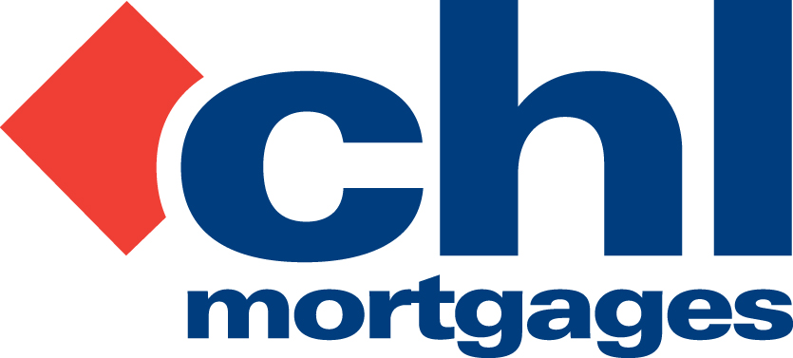

9 March 2010

PRESS RELEASE

CHL MORTGAGES HIT THE TOP TWENTY
IN SUNDAY TIMES BEST COMPANIES AWARDS

Fleet-based specialist lender, CHL Mortgages, has today (9th March 2010) announced it has achieved top twenty status at this year’s Sunday Times Best Companies Awards.

In the first year it has ever entered the Awards, CHL came 19th out of 571 companies in The UK’s 100 Best Small Companies to work for category. It is the highest-placed mortgage lender and it believes its top positioning is testament to the efforts and enthusiasm of all its staff.

The Sunday Times entry for CHL said that, ‘CHL cares for its 112 employees at work and in their own family lives’, acknowledging that this has been achieved in a particularly difficult market – mortgage lending.

The Sunday Times highlighted the fact that CHL’s staff defined its values and culture last year with the vision of, ‘A Sustainable and Well Run Mortgage Business that I can be proud to work for’. All employees have a substantial work and benefits package including private healthcare, childcare vouchers, life assurance, optional dental cover and an employee assistance programme which provides a free confidential ‘help line’ covering a range of problems for staff and their families.

Staff loyalty was also seen as a major positive for CHL with roughly a third of employees having been at the business for more than five years. 86% said they felt a strong sense of family in their teams with 89% saying they care about one another. Outstanding performers are rewarded each quarter during a special awards evening, while every month a small group goes to lunch with Managing Director, Bob Young, to give their feedback and talk about how the firm is doing.

The award comes hot on the heels of CHL achieving the top Three-Star Status in the Best Companies Accrediation Awards, an accolade only bestowed on those firms deemed to have achieved an ‘extraordinary performance’. It was one of only 50 organisations to have achieved the top honour, and one of just 13 in the South East with over 1,000 entrants in total.

Bob Young, Managing Director of CHL Mortgages, commented:

This is a fantastic achievement for the staff at CHL, who deserve recognition for reaching the top twenty out of a huge field of nearly 600 companies and to be the top mortgage lender in this category. This result has only been achieved by the efforts and enthusiasm of everyone who works at CHL. CHL’s employees and their well-being are at the heart of everything we seek to achieve at CHL and it is very rewarding to see the results of our staff surveys and to have our staff packages acknowledged as some of the best in the UK. I must give a hearty congratulations to all those who have been involved in our submission to Best Companies and, while we celebrate this achievement, work now begins to improve our placing at next year’s awards.”

For full information on CHL visit: www.chlmortgages.co.uk

PICTURE: Managing Director Bob Young accepts his award from Glen Dimelow, Director of Best Companies.
ENDS

For further information please contact:
Bob Young, Managing Director, CHL Mortgages
Tel: 01252 365890
Rob Griffiths, White Dragon Communications Ltd
Mobile: 07983 641566, Office Direct Dial: 01483 549282; rob@whitedragoncomms.co.uk

NOTES TO EDITORS

About CHL Mortgages
- CHL Mortgages has been offering specialist mortgage solutions since 1992. It is based in Fleet, Hampshire and is part of the Irish Life & Permanent Group.
- CHL Mortgages is a pioneer of both buy-to-let mortgages and self-certification mortgage products for the self-employed. It has now grown to be a leading player in these sectors.
- CHL products are designed to meet the needs of various customers, ensuring CHL Mortgages lends responsibly and treats customers fairly.

CHL Mortgages
Admiral House, Harlington Way, Fleet, Hampshire GU51 4YA
Tel: 01252 812271
Fax: 01252 811826
Website: www.chlmortgages.co.uk

