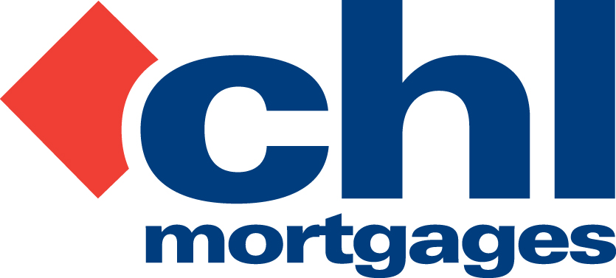

13 May 2010

PRESS RELEASE

CHL REVEALS IMPROVING ARREARS SITUATION

37% fall in gross arrears/40% fall in late arrears since February 2009 peak

Specialist lender, CHL Mortgages, has today (13th May 2010) revealed further improvements in early and late arrears across its entire buy-to-let and homeloan mortgage book.

Figures to April 2010 show CHL experienced a 37% reduction in gross arrears and a 40% reduction in late arrears (over 90 days) since its peak in February last year. Arrears are now back at levels seen in Q4 2008 and the lender expects the trend to continue for the foreseeable future.

CHL puts the improving situation down to a pro-active approach from an experienced team focused on providing practicable solutions that benefit both borrowers and the lender. CHL adopted a cautious underwriting approach during the ‘boom years’ which it says protected its mortgage book from many of the problems suffered by other lenders, particularly in the buy-to-let market.

Ahead of FSA guidance issued last year, CHL continues to deploy forbearance strategies and only considers repossession as a last resort with fees and charges also kept to a minimum.

Bob Young, Managing Director at CHL Mortgages, commented

“We are pleased to announce a continued reduction in our overall arrears position. This would not have been possible if it wasn’t for the pro-active and decisive action we have taken over the last couple of years. Even though it is still early days it seems as if our contrarian strategy is starting to pay dividends. This success is credited to a motivated team not hesitant to embrace change, but it would also be naïve not to recognise the significance a lower interest rate environment has had on our business. That said we are not complacent and we are already changing our focus to deploy an exit strategy (from accounts in receivership) which will benefit our borrowers, employees and shareholders; at present our work in this area is all about timing and execution.”

For full information on CHL visit: www.chlmortgages.co.uk

ENDS

For further information please contact:
Bob Young, Managing Director, CHL Mortgages
Tel: 01252 365890
Rob Griffiths, White Dragon Communications Ltd
Mobile: 07983 641566, Office Direct Dial: 01483 549282; rob@whitedragoncomms.co.uk

NOTES TO EDITORS

- CHL Mortgages has been offering specialist mortgage solutions since 1992. It is based in Fleet, Hampshire and is part of the Irish Life & Permanent Group.
- CHL Mortgages is a pioneer of both buy-to-let mortgages and self-certification mortgage products for the self-employed. It has now grown to be a leading player in these sectors.
- CHL products are designed to meet the needs of various customers, ensuring CHL Mortgages lends responsibly and treats customers fairly.

CHL Mortgages
Admiral House, Harlington Way, Fleet, Hampshire GU51 4YA
Tel: 01252 812271
Fax: 01252 811826
Website: www.chlmortgages.co.uk

