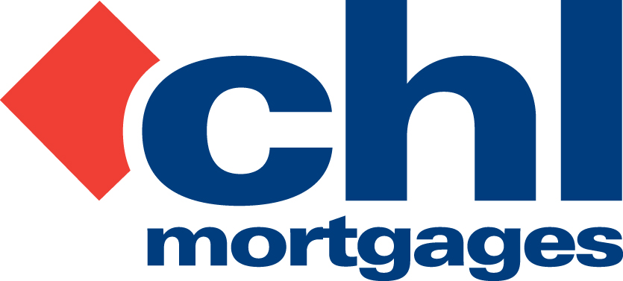

26 August 2011

PRESS RELEASE

CHL ARREARS SHOW ONGOING
QUARTERLY IMPROVEMENT

Specialist lender, CHL Mortgages, has today (26th August 2011) revealed a further quarterly improvement in the arrear levels of its buy-to-let mortgage book.

After announcing at the end of quarter one that its arrears were now back to the same levels as 2008, pre-Credit Crunch, it can now reveal a further improvement for quarter two this year.

Figures for quarter two 2011 show that only 1.77% of all CHL’s buy-to-let mortgage accounts were over 90 days in arrears. This is a 0.18% improvement on the figures for quarter one this year which were 1.94%.

These figures compare particularly favourably to the whole of (buy-to-let) market data recently published by the Council of Mortgage Lenders. 90-day arrears levels for all lenders in quarter two 2011 were 2.29%, compared to CHL’s 1.77% - a difference of 52 bps.

CHL also continue to show ongoing improvement compared to the CML index – in quarter one 2011 the comparable figures were 2.44% (CML) and 1.94% (CHL); a difference of 50 bps.

CHL anticipate further improvement in its arrears levels across its mortgage book due to its in-house collections strategy and processes, asset management and a complete emphasis on ensuring embedded TCF when dealing with borrowers.

Bob Young, Managing Director at CHL Mortgages, commented

“To be able to announce earlier this year that our arrears levels were back to pre-Credit Crunch levels was a significant moment for the business given the economic backdrop of the last few years. However, our complete focus on managing the CHL mortgage book to ensure that arrears and possessions are kept to an absolute minimum continues to work, particularly when we compare ourselves to the industry-wide figures released by the CML. CHL continues to out-perform the market in this sense; indeed we are widening the gap and believe that our in-house, TCF-focused approach to our borrowers is one of the key reasons for this.

“A huge part of this success is down to the quality, experience and skills of our collections team, both at head office and out on the road. We work with those borrowers who may be having some form of payment difficulty to ensure we come up with an individually-tailored plan and process which works for all. It is this flexible approach which is responsible for our results; we focus on human interaction with our borrowers which means dedicated teams for certain areas and certainly no predicative dialling phone systems. We believe the quality of our book will remain at the highest level and anticipate continued improvement in our arrears levels throughout the rest of 2011 and beyond.”

For full information on CHL visit: www.chlmortgages.co.uk

ENDS

For further information please contact:
Bob Young, Managing Director, CHL Mortgages
Tel: 01252 365890
Rob Griffiths, White Dragon Communications Ltd
Mobile: 07983 641566, rob@whitedragoncomms.co.uk

NOTES TO EDITORS

- CHL Mortgages has been offering specialist mortgage solutions since 1992. It is based in Fleet, Hampshire and is part of the Irish Life & Permanent Group.
- CHL Mortgages is a pioneer of both buy-to-let mortgages and self-certification mortgage products for the self-employed. It has now grown to be a leading player in these sectors.
- CHL products are designed to meet the needs of various customers, ensuring CHL Mortgages lends responsibly and treats customers fairly.

CHL Mortgages
Admiral House, Harlington Way, Fleet, Hampshire GU51 4YA
Tel: 01252 812271
Fax: 01252 811826
Website: www.chlmortgages.co.uk

