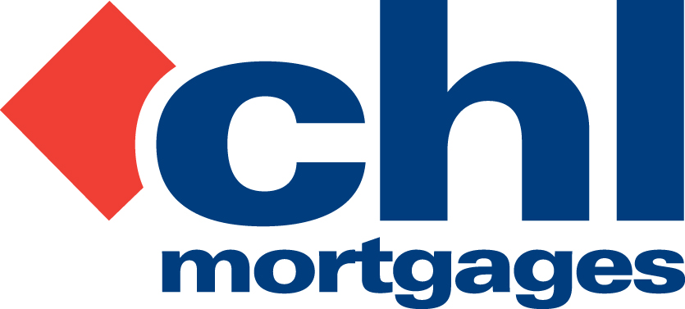

15 November 2011

PRESS RELEASE

CHL REVEALS STRONG COMPLAINTS DATA

Specialist lender, CHL Mortgages, has today (15th November 2011) revealed its complaints data for the first half of 2011, up until 30th June 2011.

In this period CHL received a total of 64 complaints, one of which was upheld by the lender itself. Only seven of those complaints were referred to the Financial Ombudsman Service (FOS), of which one of those decisions has already been decided in favour of CHL. The other six are awaiting decisions.

Alongside this, CHL have also received three other decisions from FOS for complaints submitted pre-2011; all three found in favour of CHL. The buy-to-let lender currently manages over 44,000 live mortgage accounts.

CHL’s data follows the recent publication of complaints data by FOS for individual financial businesses which covered the same period – the first half of 2011. CHL did not appear in this data as it only includes those businesses where FOS receives 30 or more complaints.

It also outlined the number of mortgages and home finance complaints received by lenders. Bank of Scotland received the highest number of mortgages home finance complaints with 590. Other lenders included Mortgage Express with 56 new complaints, GE Money with 42 and Bradford & Bingley with 35.

Bob Young, Managing Director at CHL Mortgages, commented

“It’s important that CHL is as transparent as possible when it comes to the level of complaints we receive, which is why we also detail our numbers even though we do not appear in the official FOS data. We pride ourselves on our low complaint levels, our ability to resolve them early, and the subsequent low number that are moved forward to FOS. Sharing this complaints data and benchmarking our performance against national averages is an absolute necessity as far as we’re concerned. Clearly, we compare well with other lenders, in particular, those that continue to operate or operated in our sector. We continue to work hard with our customers to ensure we are delivering a strong service in this area and we handle any complaint with sensitivity ensuring they are treated fairly. We have seen a slight rise in complaints during the first half of 2011 however this was anticipated given the nature of the mortgage market at present. CHL continues to work hard to keep complaints to an absolute minimum and to maintain our focus on treating all such matters appropriately so that a conclusion that satisfies all can be reached as quickly as possible.”

For full information on CHL visit: www.chlmortgages.co.uk

ENDS

For further information please contact:
Bob Young, Managing Director, CHL Mortgages
Tel: 01252 365890
Rob Griffiths, White Dragon Communications Ltd
Mobile: 07983 641566, rob@whitedragoncomms.co.uk

NOTES TO EDITORS

- CHL Mortgages has been offering specialist mortgage solutions since 1992. It is based in Fleet, Hampshire and is part of the Irish Life & Permanent Group.
- CHL Mortgages is a pioneer of both buy-to-let mortgages and self-certification mortgage products for the self-employed. It has now grown to be a leading player in these sectors.
- CHL products are designed to meet the needs of various customers, ensuring CHL Mortgages lends responsibly and treats customers fairly.

CHL Mortgages
Admiral House, Harlington Way, Fleet, Hampshire GU51 4YA
Tel: 01252 812271
Fax: 01252 811826
Website: www.chlmortgages.co.uk

