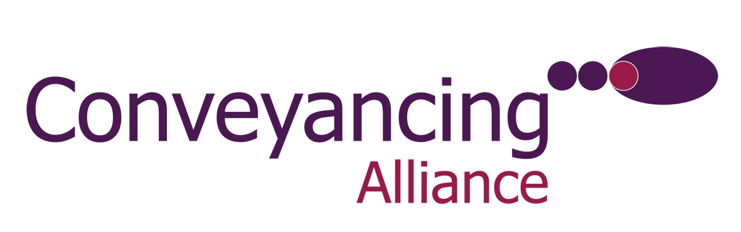
Press Release * Press Release
14 July 2009

CONVEYANCING ALLIANCE SLAMS LAND
REGISTRY FEE INCREASES

Conveyancing Alliance, the online conveyancing distributor, has today (14th July 2009) slammed the Land Registry for across the board fee increases for both its substantive applications and its information services.

A new Land Registration Fee Order came into force last week which will mean an increase for all Land Registry fees. Most fees are now more expensive by upwards of 25%, for example:
- A Scale 1 fee for a property of £250k has increased by £60 from £220 to £280.
- A Scale 2 fee for a property of the same amount has increased by £20 from £70 to £90.
- Information Services for inspection, official copy and official search have all been increased often by a third.
- There will now be a fee payable for all searches of the index map (including those which do not reveal a title number).

The Land Registry has justified the increases by citing the downturn in the property market and the deterioration in the economy as having impacted its intake of work and ‘leading to an unsustainable reduction in [its] fee income’. It says an increase in fees is the only way it can cover its operating costs.

Conveyancing Alliance believe both the timing and the actual increase of many fees cannot be justified at a time when the property market is in the doldrums and many home purchasers are having to dig even deeper to buy their homes.

Harpal Singh, Managing Director of Conveyancing Alliance, commented:

“This is just what the market doesn’t need at this time. We appreciate that fixed fees for substantive applications haven’t been increased since 1993 and fees for information services have not been increased since 2006. However, given the fragile state of the property market, we must question is now really the time to be adding to the burden of those wanting to purchase homes? At the very least the Land Registry could have postponed the fee increases. Let’s not forget that many people are already struggling to save money for a property purchase and the many other costs that come with a house move. These increases affect everyone – both buyers and sellers.”

For more information on Conveyancing Alliance, visit: www.movewithcal.co.uk

A full list of the Land Register fee changes can be found at:
www1.landregistry.gov.uk/fees/newfeeorder/

Ends

For further information, please contact:
Harpal Singh, Managing Director, Conveyancing Alliance, Tel: 0845 077 0039; E-mail: hsingh@movewithcal.co.uk
Rob Griffiths, White Dragon Communications Ltd, Tel: 01483 549282; rob@whitedragoncomms.co.uk

Notes to Editors

- An independent company, Conveyancing Alliance, was created in 2004 as a business to business distributor of property conveyancing for the mortgage intermediary and property sales markets. In January 2008, a management buy-out of Conveyancing Alliance took placed headed by managing director, Harpal Singh.
- Conveyancing Alliance’s online portal enables intermediaries to transact with its national panel of solicitor firms through absolute system integration.
- Conveyancing Alliance’s solicitors firms are carefully selected and monitored on their continued ability to demonstrate exceptional levels of service and highly competitive pricing.
- Conveyancing Alliance’s conveyancing solutions give intermediaries a valuable income stream and an element of control over their clients’ legal property transaction, as well as an additional service offering to their clients. Conveyancing Alliance offers intermediaries choice, value, control, service and simplicity.
- In 2007 Conveyancing Alliance was recognised at the Mortgage Strategy Awards and the British Mortgage Awards.
- Conveyancing Alliance also offers additional products to mortgage intermediaries and property sales professionals.

Conveyancing Alliance Ltd
25 High Street
Knaphill
Woking
Surrey
GU21 2PP
Tel: 01483 474512
Website: www.movewithcal.co.uk

