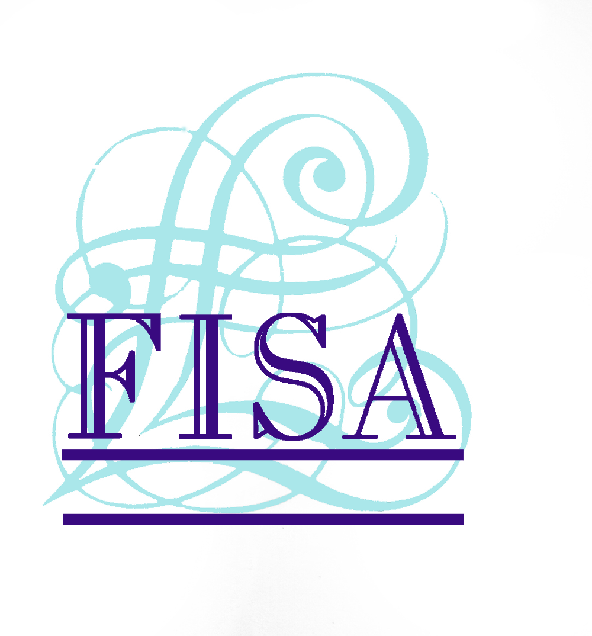

20 October 2008

FISA URGES OFT TO DELIVER FOCUSED
PROJECT ON IRRESPONSIBLE LENDING

FISA, the secured loan industry’s self-regulatory and compliance body, has today (20th October 2008) published its response to the Office of Fair Trading’s (OFT) public consultation on the scope of its project looking at irresponsible lending in UK consumer credit markets.

FISA is strongly urging the OFT to conduct a narrow and focused project which delivers a quick outcome and produces outputs that can be incorporated within the OFT licensing regime.

FISA believes the project should be focused on two areas. Firstly, the decision to lend and how the assessment of affordability is undertaken at that point - FISA favours a requirement that all lenders should have a Responsible Lending policy owned by their Board. Secondly, that for intermediated products such as secured loans, the project should deliver clarity about broker’s responsibilities in relation to the advice they give to consumers about suitable products.

FISA also believes the output of the project should be Guidance which is specific to different areas of consumer credit as the lending decisions vary greatly, however, the OFT needs to ensure that no one area of consumer credit receives a competitive advantage over another
.
John Parker, Chief Executive of FISA, commented:

"FISA recognises the importance of this OFT project and has been involved from a very early stage. In the current economic and political climate the need to avoid irresponsible lending is of critical importance. It is all the more important that the project focuses on the right areas and delivers its output in a short space of time. We believe there is little to be gained from the OFT looking at areas such as advertising, the sale of associated products and account management, all of which are already subject to regulation by the OFT, FSA and other bodies. Producing guidance to help define the responsibilities of both lenders and brokers will be of major importance and we look forward to continuing our work with the OFT to help the shape the project.”

For more information on the Finance Industry Standards Association (FISA) and to view the full response, visit: www.fisa.co.uk

ENDS

For further information please contact:
John Parker, Chief Executive, FISA, Mobile: 07872 030866
Rob Griffiths, White Dragon Communications Ltd, Tel: 01483 892740, Mobile: 07983 641566; rob@whitedragoncomms.co.uk

Notes to editors

- The Finance Industry Standards Association (FISA) is a self-regulatory and compliance body operating in the broker-introduced secured loan market. It was formed in 1988.
- FISA has six lender and approximately 256 broker members which transact over 80% of business in the secured loan sector. FISA requires its members to comply with all laws and regulations and the FISA Code of Conduct.
- To assist its members in complying with Consumer Credit Act and FSA regulation, FISA provides a range of services including a telephone advice service, compliance health checks, pre-vetting of advertising and industry-leading training.

Finance Industry Standards Association (FISA)
24 Boston Road
Sleaford
Lincolnshire
NG34 7ET
Tel: 01529 305698
Fax: 01529 308755

