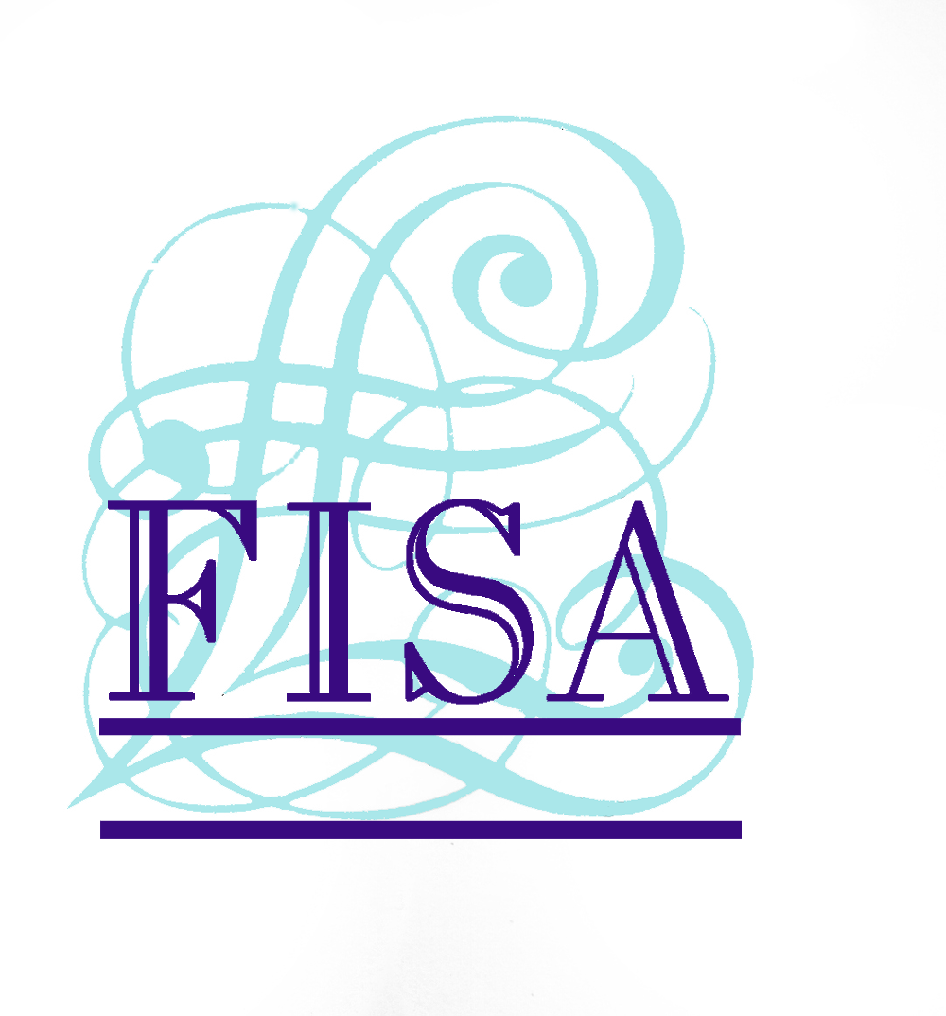

13 October 2008

NEW FISA BOARD OUTLINES KEY PROJECTS

FISA, the secured loan industry’s self-regulatory and compliance body, has today (13th October 2008) announced a range of key projects following the first meeting of its reconstituted Board on 8 October 2008.

Top of the agenda for the new FISA Board, which now has equal numbers of Directors representing broker and lender members, was the role the body will play in helping the secured loan industry achieve more consistent compliance with the rules of the OFT, FSA and other statutory regulators, including the way products are advertised. The Board agreed that only by achieving greater compliance can the industry protect itself when complaints are brought with the Financial Ombudsman Service (FOS).

In order to improve compliance levels, FISA will provide a range of active support for its members including telephone-based advice, seminars and other guidance. FISA has also pledged to work actively with the OFT to ensure action is taken against non-compliant firms to create a level playing field across the industry. Chairman of FISA, Phil Nunnerley, and Chief Executive, John Parker, are to hold discussions with senior OFT officials regarding how the two organisations can best work together and the need for action against non-compliant firms.

The new Board also approved the rewriting of the FISA Code, acknowledging that, while it was important in encapsulating what the industry needed to adhere to, it had become outdated. The Code will now be rewritten in two parts, one for consumers and one for FISA brokers and lenders. The new Code, drawing on the Treating Customers Fairly initiative and the provision of the Non-status Guidelines, will set out what consumers can expect when they deal with FISA brokers and lenders. The second part of the Code will set out the good practice which FISA brokers and lenders will be expected to adhere to in their dealings with each other, for their mutual protection.

The Board has also pledged to rewrite the FISA Borrowers' Guide to make it more consumer-friendly, while ensuring that it continues to provide protection to firms in the event of complaints.

The Board also considered the OFT's current consultation on its Irresponsible Lending project which covers all types of consumer credit. FISA is concerned that the scope of the project will be too widely drawn if it includes matters such as advertising, the sale of associated products and account management. FISA believes the OFT project should focus on the lending decision and the assessment of affordability at that point, rather than one which looks at all parts of the value chain and takes over a year to deliver guidance. As regards intermediated products such as secured loans, the OFT should also provide clarity about the responsibility of brokers.

Phil Nunnerley, Independent Chairman of FISA, commented:

"The secured loan sector is facing many challenges, with the whole mortgage sector being in the political and media spotlight. FISA now has a Board of senior brokers and lenders who together can provide the leadership the industry needs in these times. I am delighted that there was consensus about the way forward and the initial projects FISA will be undertaking. The Board is unanimous in its agreement that there needs to be consistent compliance across the sector, that working in partnership with the OFT will be of critical importance, and that we need to revise the FISA Code so that it has meaning for both consumers and for firms in the industry.

“Like all membership organisations FISA needs to demonstrate the benefits that accrue from being a member. One of the challenges set by the Board is that FISA needs to set out clearly what those benefits are, and work actively to encourage lenders and brokers which are not currently members to join. This will be a key focus for FISA in the months ahead."

For more information on the Finance Industry Standards Association (FISA), visit: www.fisa.co.uk

ENDS

For further information please contact:
John Parker, Chief Executive, FISA, Mobile: 07872 030866
Rob Griffiths, White Dragon Communications Ltd, Tel: 01483 892740, Mobile: 07983 641566; rob@whitedragoncomms.co.uk

Notes to editors

- The Finance Industry Standards Association (FISA) is a self-regulatory and compliance body operating in the broker-introduced secured loan market. It was formed in 1988.
- FISA has six lender and approximately 256 broker members which transact over 80% of business in the secured loan sector. FISA requires its members to comply with all laws and regulations and the FISA Code of Conduct.
- To assist its members in complying with Consumer Credit Act and FSA regulation, FISA provides a range of services including a telephone advice service, compliance health checks, pre-vetting of advertising and industry-leading training.

Finance Industry Standards Association (FISA)
24 Boston Road
Sleaford
Lincolnshire
NG34 7ET
Tel: 01529 305698
Fax: 01529 308755

