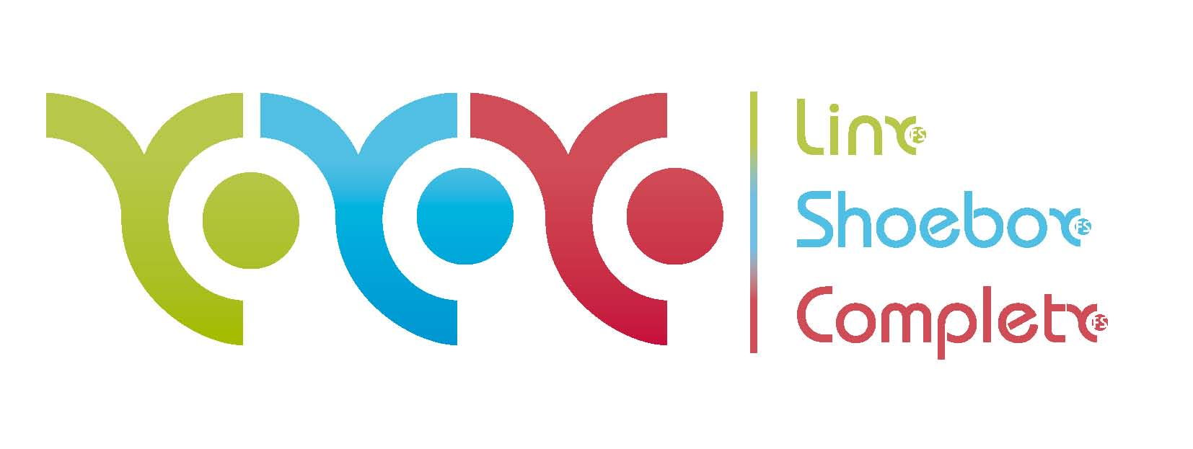

PRESS RELEASE – 9 June 2010

Linx FS adds free business development workshop dates

Due to increased broker demand Linx FS has added two more dates to its series of free business development workshops aimed at maximising the sales potential of its recently launched Shoebox proposition.

The workshops have been taking place in a specially constructed training suite at the Linx FS headquarters throughout the first week in June and have been extended to include two more dates on the 22th and 24th June with limited places still available. The workshops aim to demonstrate the numerous income opportunities generated by the Shoebox system, as well as the benefits to the intermediary of a clients information all being stored in one place. To register for one of the events brokers need to contact the sales team at Linx FS on 02380 456999.

The Shoebox platform gives brokers access to over 30 financial products in areas such as pensions, bonds, SIPPs, child savings accounts, annuities and share dealings as well as other areas of client expenditure. Shoebox is a free total business solution to help brokers develop and grow their business in a friendly, professional and secure manner by utilising the system to access, maintain, analyse and manage their entire client’s financial information securely online.

Clients will have full access to Shoebox but upon introducing clients to the system brokers will be in place to earn referral income for any transactions placed through this vehicle. Shoebox uses its in-depth industry knowledge to provide information that keeps the client up to date on what they’ve got, why they’ve got it and what its worth. It also produces automatic prompts and alerts that help clients and brokers ensure important dates and reviews are not missed.

Full details of the Shoebox proposition are available at www.linx-fs.co.uk. Shoebox is specifically aimed at mortgage brokers, protection advisers and introducers who have built up a good client bank.

Phil Jay, director at Linx FS commented:

“We believe using Shoebox can increase a broker’s income by as much as 25% and we’ve been delighted at how the launch has been received by the intermediary market. The workshops have proved very successful in transferring initial interest in the system into real enthusiasm for its potential and due to demand we have added the two extra dates. However, these workshops are just the beginning and we are committed to providing full training and support for brokers to best utilise the vast potential that Shoebox can offer across numerous areas of financial products services.”

ENDS

For further information please contact:
Phil Jay, director at Linx FS; Mobile 07957 443573; phil.jay@linx-fs.co.uk
Bob Hope, director at Linx FS; Mobile 07889 669642 bob.hope@linx-fs.co.uk
Scott Philipson, White Dragon Communications Ltd, Mobile: 07786 226520; scott@whitedragoncomms.co.uk

Notes to editors

Linx FS was established in November 2009 by Phil Jay and Bob Hope, the former managing director and sales director of BDS Mortgage Group.

Linx FS provides a total business solution to mortgage and insurance intermediaries, helping them to develop and grow their business ain a fully compliant manner. By joining Linx FS brokers will receive;

- Full access to mortgage clubs and whole of market lending
- Full access to extensive life & GI products
- Sales and training events
- Experienced management team, dedicated business and processing support
- Trigold and Complianceshield mortgage sourcing system
- Free marketing support
- Exclusive access to Shoebox
- Simple and highly competitive charging structure
- Regular group forums
- Ability to convert to investment adviser
- Free lead generation for mortgages

Linx FS Ltd
9 Compass Point
Ensign Way
Hamble
Southampton
Hants
SO31 4RA

