DATE: 29 OCTOBER 2008

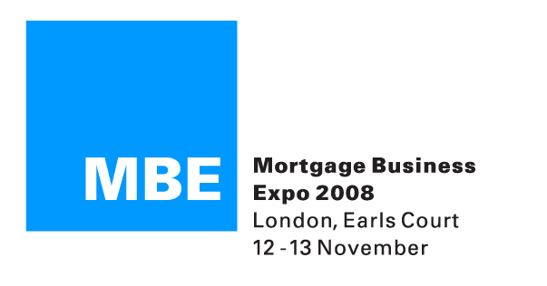

PRESS RELEASE

BROKERS TO GET THE 360 DEGREE TREATMENT AT MBE LONDON 2008

MBE London, the UK’s biggest event for financial intermediaries, has today (29th October 2008) revealed details of its 360 Degree Broker Zone launching at the exhibition for the first time on the 12th and 13th November at Earl’s Court 2.

The dedicated 360 Degree Broker Zone is designed to help delegates provide a 360 degree service to their clients identifying all cross-selling and commission-earning opportunities. The Zone will include providers ready to advise on how brokers can sell their products alongside their regular mortgage business.

To help brokers identify other income generating sectors outside of residential mortgages, MBE London will offer delegates the 360 Degree Broker Seminar Theatre, with a programme put together by the Association of Mortgage Intermediaries (AMI) and the Association of Finance Brokers (AFB).

Within the theatre industry experts from a variety of fields will provide practical advice with sessions on selling additional income products. The seminar sessions will cover:
- Protection – Bonnie Burns, Legal & General.
- Equity Release – Andrea Rozario, SHIP.
- General Insurance – Bruce Reid, Select & Protect.
- Debt Management and IVAs – Gareth Neill, Grant Thornton.
- Overseas Mortgages – Simon Conn, Conti Financial Services.

Daniel Nwaokolo, MBE London 2008 Director, commented:

“The 360 Degree Broker Zone is a new addition to MBE London and one which we believe delegates will find of great use and interest. This year’s exhibition has business diversification as its central theme and the 360 Degree concept has been designed to deliver information on product areas outside the traditional mortgage business. We are offering delegates access to a variety of providers in areas such as equity release, protection, debt management, to name but a few, plus the added extra of seminar sessions delivering practical help and support on how to get the most out of these sectors. Clients have a variety of different financial product needs and it is important that advisers are able to operate in numerous sectors to ensure their client has access to these products and that they can maximise their income. The 360 Degree Zone is a major part of MBE London 2008 and we believe delegates will find numerous income-generating ideas from a visit to Earl’s Court 2 next month.”

Chris McFarlane, LV= Head of Protection, said:

“The Zone provides an excellent opportunity for advisers to learn about different income stream opportunities that they can tap into. At LV= we’re looking forward to meeting event visitors at the Zone and to sharing some powerful and practical guidance, with a hard-hitting film that can be shown to clients and a truly revolutionary mortgage protection product that is build around the real needs of homeowners.”

To gain full information on the Show and to register for free entry, intermediaries should visit: www.mortgagebusinessexpo.co.uk

ENDS

NOTES TO EDITORS
- This year’s MBE London will take place on 12 and 13 November at Earl’s Court 2 in London.
- Opening times for the show are: 9.30-5.30 (Wednesday 12 November) and 9.30-5 (Thursday 13 November).
- The MBE London and Manchester shows have become established and vital events for intermediaries and independent financial advisers putting them in direct contact with lenders, product providers and investment companies.

FURTHER INFORMATION

For more information on MBE London, please contact Rob Griffiths at White Dragon Communications Ltd on:
Tel: 01483 549282
Mobile: 07983 641566
E-mail: rob@whitedragoncomms.co.uk

If you are a journalist and would like to attend this year’s MBE London, please e-mail Helen Omoh with your name, job title, publication and address to helen.omoh@clarionevents.com

