DATE: 20 OCTOBER 2008

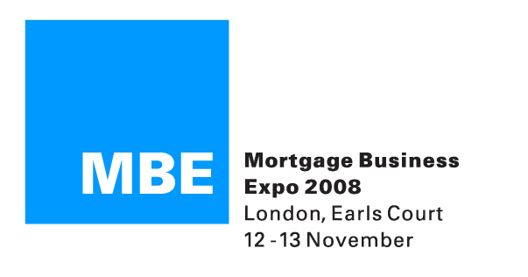

PRESS RELEASE

MBE LONDON 2008 REVEALS NEW NETWORK RECRUITMENT
AND PRODUCT SHOWCASE THEATRE

MBE London, the UK’s biggest event for financial intermediaries, has today (20th October 2008) revealed the contents of its new Network Recruitment and Product Showcase Theatre.

The new Theatre has been put together to allow delegates to hear the latest Network and Product news, and receive information from a range of MBE exhibitors, and leading industry names.

Prospective appointed representatives (ARs) looking for a network home or those current ARs looking to change network partner will be able to hear from three Principals - Lime, Vision Network and Legal & General - who will be presenting on the benefits of joining their networks. Other networks will be exhibiting at the event.

The Networks will also be on hand to help intermediaries gain access to non-exhibiting lenders, such as Abbey for Intermediaries, Halifax, BM Solutions, Bank of Scotland, Intelligent Finance, Cheltenham & Gloucester, The Woolwich, Bristol & West, Alliance & Leicester and Standard Life.

The Network Theatre presentations will feature presentations from:
- Legal & General - Karen Blatchford, Commercial and Marketing Director and Darrel Stone, National Head of Recruitment/Strategic Partnerships.
- The Vision Network - Paul McGuirke, Sales Director.
- Lime - Neil Burrows, Sales Director.

The Product Showcase presentations will feature the following companies presenting on a wide variety of offerings including:
- LV= - Income Protection, John Crutchley, sponsored by LV=.
- Lloyds TSB International - Overseas Property Finance, Simon Kidney, Senior Manager, International Mortgages.
- Blue Sky Invest - Complimentary products such as Debt Management, Secured Loans, Overseas Investments and Overseas Mortgages, Simon Betts, Managing Director.
- Bridgingloans.com - Bridging Loans, Ryneveld van der Horst, Finance Director and Martyn Smith, Managing Director.
- Aegon – Protection, Andy Walton, National Sales Manger and Mark Godding, Sales Development Manager.

Daniel Nwaokolo, MBE London 2008 Director, commented:

“This new Network Recruitment and Product Showcase is another opportunity for delegates to hear about the latest offerings in a variety of sectors. In the current climate many AR firms may be looking to move networks or there may be directly authorised firms considering a move to AR status. The network firms presenting at Expo will be able to share with delegates the low down on their own propositions and the reasons why they are worth consideration. This year’s Expo is all about business diversification and making the most of the client base – this is why we also have a number of firms presenting on a wide range of products including protection, overseas finance and debt management, to name but a few. Delegates will be treated to industry experts outlining the benefits of these products for both adviser and client and where they may be suitable, particularly in a time of financial instability.”

Payam Azadi, Marketing Director at Vision Network/The Mortgage Times Group, said:

“MBE London continues to be one of the major showcases for Mortgage Times and we believe there is huge merit in exhibiting there. Expo is always a major date in our calendar and with the addition of this new Theatre we are sure large numbers of intermediaries and advisers will be making the journey to Earl’s Court 2 next month. While many of our competitors have cut back we are always keen to talk to brokers about the market opportunities that still exist and how we can help them access these offerings. This is why we will be using our presentations at the Network Recruitment Theatre to talk to brokers about the benefits of the Vision Network proposition and where we can help them grow and develop their businesses. We are looking forward to engaging with the advisory community next month at MBE London.”

This year’s MBE London is focused on business diversification and includes over 140 exhibitors, three seminar theatres and three zones. Amongst the new features at this year’s show is the 360 Degree Broker Zone, designed to help delegates provide a 360 degree service to their clients identifying all cross-selling and commission-earning opportunities.

To gain full information on the Show and to register for free entry, intermediaries should visit: www.mortgagebusinessexpo.co.uk

ENDS

NOTES TO EDITORS
- This year’s MBE London will take place on 12 and 13 November at Earl’s Court 2 in London.
- Opening times for the show are: 9.30-5.30 (Wednesday 12 November) and 9.30-5 (Thursday 13 November).
- The MBE London and Manchester shows have become established and vital events for intermediaries and independent financial advisers putting them in direct contact with lenders, product providers and investment companies.

FURTHER INFORMATION

For more information on MBE London, please contact Rob Griffiths at White Dragon Communications Ltd on:
Tel: 01483 549282
Mobile: 07983 641566
E-mail: rob@whitedragoncomms.co.uk

If you are a journalist and would like to attend this year’s MBE London, please e-mail Laila Anbar with your details to laila.anbar@clarionevents.com

