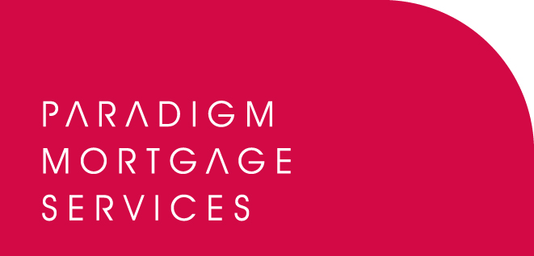

30 September 2011

MIKE ALLISON JOINS PARADIGM MORTGAGE SERVICES

Paradigm Mortgage Services, the mortgage services proposition, has today (30th September 2011) announced the appointment of Mike Allison, who is joining the business to support its Partnership Development team.

Allison will be working with Paradigm’s firms in order to support their existing needs and to develop new value-generating opportunities. He will be particularly active in key areas such as compliance services ensuring that Partner firms have everything in place to meet their responsibilities.

Allison also has a specific role within Paradigm Mortgage Services to develop its existing protection proposition and to ensure Partner firms are maximising their advice capability in this product sector.

Allison joins Paradigm Mortgage Services from sister firm, Paradigm Financial Advisers (PFA), the network proposition for appointed representative firms. Allison joined PFA in January 2010; prior to this he was the Managing Director of Personal Touch Financial Services.

Bob Hunt, Chief Executive of Paradigm Mortgage Services, commented:

“We are pleased to welcome an individual of Mike’s experience and skills to the Paradigm Mortgage Services team. Our membership levels and positive resultant business growth continues to buck trends in this continuingly difficult market. We believe now is the time to enhance our existing Partnership Development team and to add someone of Mike’s experience is very exciting. At Paradigm we are always looking at the key areas where firms require support, and Mike’s knowledge in supporting new and existing members’ compliance needs along with a focus on developing our already strong protection proposition should prove very popular. ”

Mike Allison, Partnership Development at Paradigm Mortgage Services, commented:

“I am delighted to be working at Paradigm Mortgage Services helping develop further this tremendous proposition for directly authorised firms. Since joining Paradigm Group I have been impressed both with their vision of the future and the infrastructure in place to support the services they provide to members. Paradigm Mortgage Services has grown, in a short space of time, to be one of the UK’s major distributors and I am looking forward to working with our Partner firms in order to help them maximise their business value and volume. The whole Paradigm ethos is one that has the adviser as its focus and I am excited to be part of the next stage of its growth.”

To view the new Paradigm Mortgage Services’ website, please visit: www.paradigmmortgages.com

ENDS

For further information please contact:
Bob Hunt, Chief Executive, Paradigm Mortgage Services, Mobile: 07767 462092
Rob Griffiths, White Dragon Communications Ltd, Mobile: 07983 641566; rob@whitedragoncomms.co.uk

Notes to editors

About Paradigm Mortgage Services
- Paradigm Mortgage Services offers IFAs and mortgage intermediaries the same opportunity. Members of the proposition benefit fully from market-leading procuration fees, have access to exclusive and semi-exclusive products, and share in the club’s ownership. Members will also have the added opportunity of building additional value wholly attributable to their own individual businesses. Paradigm Mortgage Services also offer a dedicated Mortgage Desk to members.
- Paradigm Mortgage Services is an associated business of Paradigm Partners LLP, the IFA support firm established by Paul Hogarth.
- Paradigm Partners is a limited liability partnership. It offers those firms who sign up the opportunity for them to share in the capital growth of the business via a discretionary trust.

Paradigm Partners LLP
Paradigm House
Brooke Court
Wilmslow
Cheshire
SK9 3ND
Tel: 0845 303 6333
Fax: 0845 303 8333

Paradigm Mortgage Services
Wellington House
Birmingham International Park
Solihull
West Midlands
B37 7HE
Tel: 0121-781 7337/7338
Fax: 0121-731 7339

