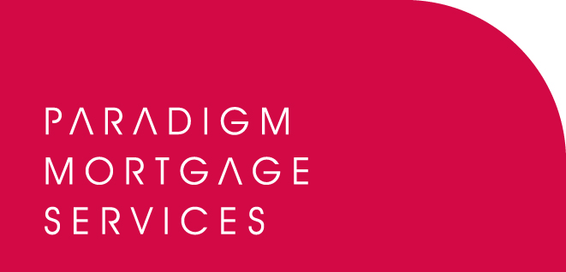

26 October 2009

PARADIGM GROUP ANNOUNCE FORTIS LIFE AS
NEW STRATEGIC PARTNER

Paradigm Group, the IFA support services and mortgage partnership proposition, has today (26th October 2009) announced UK insurer, Fortis Life as its new strategic partner.

From today, Paradigm members will be able to access Fortis Life’s range of life protection insurance through the Paradigm Mortgage Services’ preferred protection panel.

Fortis Life UK was established in 2008 and now has over 45,000 customers in the UK. It offers two products: YourLife Plan is a menu product offering Term Assurance, Critical Illness Cover, Family Income Benefit and Income Protection;
Real Life Cover is for customers who know they need more than just Life Assurance but see traditional products as too expensive or complicated – it provides a package of seven covers plus the option of unemployment insurance.

Fortis Life UK joins Paradigm’s whole of market preferred protection market proposition which offers members excellent commercial terms. The panel only includes those providers who have given a commitment to work closely with Paradigm in support of its members.

From today Fortis Life’s proposition will appear on the various quotation engines. Directly authorised brokers who wish to do business with Fortis Life can therefore visit the website at www.paradigmmortgages.com and click on the ‘Protection’ tab.

Bob Hunt, Chief Executive of Paradigm Mortgage Services, commented:

“We are delighted to welcome Fortis Life UK as the newest strategic partner of Paradigm Group. As a business committed to offering the widest range of products and services to our members it is important that we continue to embrace organisations who have something unique to offer. Fortis Life’s range of protection products certainly fit this category, as does their intuitive and forward-thinking processes, and we are sure Paradigm members will be as enthused as we are about the propositions available. Once again we are partnering with a company committed to working closely with Paradigm members to get the best for them and their clients. We believe this is the beginning of a strong relationship between Paradigm, Fortis Life and all our member firms.”

Martin Werth, Managing Director of Fortis Life UK, said:

“We are delighted to announce our partnership with Paradigm Group. Paradigm shares our commitment to providing advisers and customers alike with the products they need and the level of service they deserve. We very much look forward to working with Paradigm and their member firms to help close the protection gap.”

ENDS

For further information please contact:
Bob Hunt, Chief Executive, Paradigm Mortgage Services, Tel: 07767 462092
Fortis UK Press Office, Tel: 023 8035 2754; press.uk@fortis-uk.com
Rob Griffiths, White Dragon Communications Ltd, Tel: 01483 549282, Mobile: 07983 641566; rob@whitedragoncomms.co.uk

Notes to editors

About Paradigm Mortgage Services
- Paradigm Mortgage Services offers IFAs and mortgage intermediaries the same opportunity. Members of the proposition benefit fully from market-leading procuration fees, have access to exclusive and semi-exclusive products, and share in the club’s ownership. Members will also have the added opportunity of building additional value wholly attributable to their own individual businesses. Paradigm Mortgage Services also offer a dedicated Mortgage Desk to members.
- Paradigm Mortgage Services is an associated business of Paradigm Partners LLP, the IFA support firm established by Paul Hogarth.
- Paradigm Partners is a limited liability partnership. It offers those firms who sign up the opportunity for them to share in the capital growth of the business via a discretionary trust.

Paradigm Partners LLP
Paradigm House
Brooke Court
Wilmslow
Cheshire
SK9 3ND
Tel: 0845 303 6333
Fax: 0845 303 8333

Paradigm Mortgage Services
Wellington House
Birmingham International Park
Solihull
West Midlands
B37 7HE
Tel: 0121-781 7337/7338
Fax: 0121-731 7339

