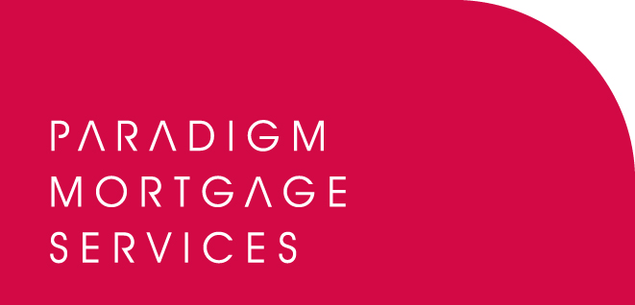

8 September 2008

PARADIGM MORTGAGE SERVICES
LINKS WITH LONDON & EUROPEAN

Paradigm Mortgage Services, the mortgage partnership proposition, has today (8th September 2008) announced the addition of London & European to its conveyancing panel.

The link up means that Paradigm members will now have access to London & European’s brand new Complete Conveyancing product. Complete Conveyancing is a web-based conveyancing and panel management system for remortgages, sales and purchases.

The system links all parts of the value chain from borrower to broker to lender to conveyancer and estate agent. It is the only online management system that takes control of the transaction process to set target completion dates upon instruction for remortgages, and gives brokers crucial and timely information to help manage the client accordingly.

For the first time the new Complete Conveyancing system allows fully integrated electronic data transfer through a choice of PDF and Excel in any direction, allowing for fast, simple and transparent data transfer between all parties. The 24/7 online case tracking is available to all stakeholders and this transparency of process is proven to deliver quicker results with offer to completion timescales on remortgages being reduced by up to 70%.

Paradigm Mortgage Services is a mortgage partnership proposition open to mortgage intermediary firms offering access to lenders covering the whole of the market, coupled with a range of mortgage-related support services. These services include lending and provider panels for equity release, secured lending, bridging finance, protection and general insurance.

John Coffield, Head of Paradigm Mortgage Services, commented:

“We are delighted to announce the addition of London & European to the Paradigm Mortgage Services conveyancing panel. Paradigm members now have a number of options available to them and we are sure they will benefit from London & European’s experience in this market and in particular the brand new Complete Conveyancing system. The Paradigm Mortgage Services proposition continues to grow and evolve, and with partners such as L&E we can deliver real value and a true partnership for all those involved with Paradigm. All intermediary firms are advised to visit our website to find out about the benefits of Paradigm membership.”

Christopher Taylor, CEO of London & European, said:

“Complete Conveyancing has been designed to break down the barriers to doing business. It is quick and simple to use – brokers don’t even need to register to get a quote – and it only takes two minutes to submit an instruction. Paradigm’s members can now access what we believe is the new gold standard in online conveyancing and take advantage of a new revenue generating tool.”

For more information on Paradigm Mortgage Services, visit: www.paradigmmortgages.com

For more information on London & European, visit:
www.europeantitle.com

ENDS
For further information please contact:
John Coffield, Head of Paradigm Mortgage Services, Tel: 07825 613012
Rob Griffiths, White Dragon Communications Ltd, Tel: 01483 549282, Mobile: 07983 641566; rob@whitedragoncomms.co.uk

For further information on London & European please contact:
Christopher Taylor, Chief Executive Officer of London & European, Tel: 020 7929 7650
Lesley Russell, Spotlight Communications Ltd, Tel: 05600 040835, Mobile: 07815 778038

Notes to editors

About Paradigm Mortgage Services
- Paradigm Mortgage Services offers IFAs and mortgage intermediaries the same opportunity. Members of the proposition benefit fully from market-leading procuration fees, have access to exclusive and semi-exclusive products, and share in the club’s ownership. Members will also have the added opportunity of building additional value wholly attributable to their own individual businesses. Paradigm Mortgage Services also offer a dedicated Mortgage Desk to members.
- Paradigm Mortgage Services is an associated business of Paradigm Partners Ltd, the IFA support firm established by Paul Hogarth.
- Paradigm Partners is a limited liability partnership. It offers those firms who sign up the opportunity for them to share in the capital growth of the business via a discretionary trust.
- London & European is a leading provider of services and solutions designed to enhance the speed, simplicity and security of property transactions.
- Established in 1994 and headquartered in the City of London, London & European introduced the concept of title insurance to the UK and established itself as a leader in this sector of the insurance market.
- The group was acquired in 2001 by the APRIL Group, an insurance services architect quoted on the French stock exchange.
- APRIL generated sales of €604 million and a net profit of €72 million in 2007. It currently has a market capitalisation of €1.6 billion.

Paradigm Partners LLP
Paradigm House
Brooke Court
Wilmslow
Cheshire
SK9 3ND
Tel: 0845 303 6333
Fax: 0845 303 8333

Paradigm Mortgage Services
Wellington House
Birmingham International Park
Solihull
West Midlands
B37 7HE
Tel: 0121-781 7337/7338
Fax: 0121-731 7339

