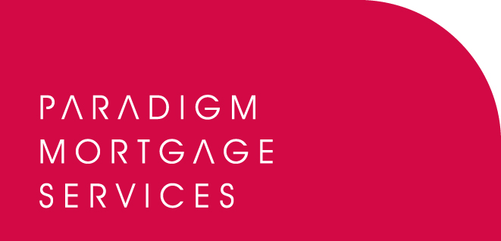

21 October 2008

PARADIGM ADDS PROMISE SOLUTIONS TO SECURED LOANS OFFERING

Paradigm Mortgage Services, the mortgage partnership proposition, has today (21st October 2008) announced Promise Solutions as its new preferred partner for secured lending.

Promise Solutions is one of the leading sourcing and packaging solutions available in the UK today. With its addition to the Paradigm secured lending offering members will now be able to access:
- Leading commission rates.
- Whole of market secured loan provider panel.
- Free 24/7 online sourcing, quoting and document production.
- Loan optimisation tools.
- Direct links to lender scoring.
- Full in-house underwriting, packaging and IT support.
- Regular management information in the format they require.
- Case tracking and viewing.
- Marketing toolbox.
- Unique “lender refresh” enabling Promise to advise brokers on all previously declined applications which now fit criteria following the introduction of new products/lenders.

Paradigm members will be able to learn more about the Promise proposition by visiting the Paradigm website at: www.paradigmmortgages.com and clicking on the ‘Secured’ tab’.

Paradigm Mortgage Services offers a partnership model for mortgage intermediaries and IFAs delivering greater value and additional income from their placed business, coupled with a share in the equity of the partnership. It also offers a range of support services including new income streams and cross-selling initiatives.

Bob Hunt, Chief Executive of Paradigm Mortgage Services, commented:

“We are delighted to announce Promise Solutions as our latest preferred partner for secured lending. Paradigm exists to provide our members with a host of opportunities to grow their income levels through our relationships with the UK’s leading providers of financial products. The addition of Promise Solutions delivers a new avenue for members to access secured loans through and a whole new range of services. Through Promise Solutions our members are guaranteed top quality levels of service and support coupled with market-leading commission earnings. We look forward to working the Promise team and urge our members and other advisory firms to review this new offering and the overall Paradigm proposition.”

Steve Walker, Managing Director of Promise Solutions, said:

“I am a great fan of Paradigm’s business model and we are very pleased to be associated with such a fast growing organisation. Our technology and additional support allows us to remove the mystery associated with secured loans and empower Paradigm’s members to generate significant additional income and to become relative experts in the field. As both a Master Broker and a technology provider we can create bespoke solutions specifically tailored to member’s needs and help them differentiate themselves in the current challenging market.”

For more information on Paradigm Mortgage Services, visit: www.paradigmmortgages.com

For more information on Promise Solutions, visit: www.promisesolutions.co.uk

ENDS
For further information please contact:
Bob Hunt, Chief Executive, Paradigm Mortgage Services, Tel: 07767 462092
Steve Walker, Managing Director, Promise Solutions, Tel 01902 378378
Rob Griffiths, White Dragon Communications Ltd, Tel: 01483 549282, Mobile: 07983 641566; rob@whitedragoncomms.co.uk

Notes to editors

About Paradigm Mortgage Services
- Paradigm Mortgage Services offers IFAs and mortgage intermediaries the same opportunity. Members of the proposition benefit fully from market-leading procuration fees, have access to exclusive and semi-exclusive products, and share in the club’s ownership. Members will also have the added opportunity of building additional value wholly attributable to their own individual businesses. Paradigm Mortgage Services also offer a dedicated Mortgage Desk to members.
- Paradigm Mortgage Services is an associated business of Paradigm Partners LLP, the IFA support firm established by Paul Hogarth.
- Paradigm Partners is a limited liability partnership. It offers those firms who sign up the opportunity for them to share in the capital growth of the business via a discretionary trust.

About Promise Solutions
Promise Solutions Group comprises:
- Promise Solutions Ltd - offering secured loans and unsecured loans direct to consumers and through introducers plus secured loan sourcing technology to brokers.
- Promise Financial Services Ltd - offering bespoke contact centre services to the finance sector.
- Promise Debt Solutions Ltd - offering debt management and IVAs.
- Promise Homepacks - providers of home information packs to businesses and consumers plus HIP technology to Hip providers and DEA’s.
- Promise Dreams – registered charity to help seriously ill and terminally ill children. Administered and supported by Promise Solutions – raised almost £2 million.

Paradigm Partners LLP
Paradigm House
Brooke Court
Wilmslow
Cheshire
SK9 3ND
Tel: 0845 303 6333
Fax: 0845 303 8333

Paradigm Mortgage Services
Wellington House
Birmingham International Park
Solihull
West Midlands
B37 7HE
Tel: 0121-781 7337/7338
Fax: 0121-731 7339

Promise Solutions Ltd
Promise House
Stafford Road
Wolverhampton
West Midlands
WV10 6AD
Tel; 01902 378378
Fax; 01902 378379

