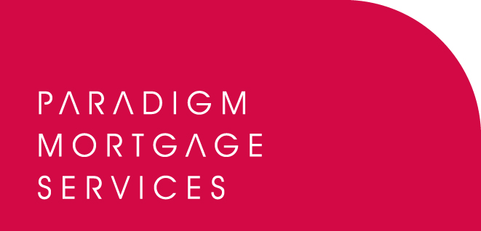

20 July 2011

PARADIGM ADD LOWRY CAPITAL TO
BRIDGING LENDER PANEL

Paradigm Mortgage Services, the mortgage partnership proposition, has today (20th July 2011) added Lowry Capital to its panel of bridging loan lenders.

Manchester-based Lowry Capital offer bridging finance solutions to customers throughout England, Scotland and Wales with a focus on a bespoke, flexible approach to lending. Lowry Capital can offer loans to a broad range of clients including individuals whose property investment chain has broken down through to large investors and Corporations.

From today, Paradigm members will be able to access the lender through the Paradigm panel. Lowry Capital offers brokers and their clients a number of advantages including:
- Direct contact with a decision maker who will provide an instant decision.
- Small and large loans from £25k upwards.
- Lending up to 75% of Open Market Value.
- No upfront fees – fees are only payable when the loan completes
- Express ‘Refurbishment’ product.- Funding refurbishment properties
- Exceptional customer service – instant over the phone decisions, written DIPs within minutes, valuations within 24 hours, and a legal pack issued within two hours.

Paradigm member will also benefit from particularly competitive terms and commissions include procuration and broker fees, plus additional bonuses.

Also for an initial period of two months, Lowry Capital is offering Paradigm members a bonus of up to £500 per completed application. For loans up to £250k the bonus will be £250; for loans over £250k the bonus will be £500.

John Coffield, Head of Paradigm Mortgage Services, commented:

“Demand for bridging and short-term finance continues to grow and Paradigm is keen to offer our members access to some of the best-known, quality providers in the marketplace today. Lowry Capital’s addition to our overall bridging loan proposition opens up a further finance avenue for advisers and their clients. Lowry offers a range of finance opportunities for an increasingly wide range of clients and importantly treats each individual case on its merits, providing a bespoke offering depending on a client’s needs. This is a marketplace which is likely to grow further particularly in an environment where appetite to lend amongst the mainstream lending community is still low. Bridgers and short-term financiers are certainly fulfilling a real need in today’s economic environment and we are pleased to welcome Lowry Capital to our panel.”

Richard Basso, Director at Lowry Capital, said:

"Lowry Capital is fully focused on providing a first class bridging service to Intermediaries; we are therefore delighted to be working closely with Paradigm Mortgage Services. We look forward to providing their members with our award-winning service and bespoke funding options, where at all times they will speak directly to a key decision maker. We will be providing access to lending throughout England, Scotland & Wales.”

For more information on Paradigm Mortgage Services’ bridging loan proposition, please visit: www.paradigmmortgages.com and click on the ‘Bridging’ tab.

For more information on Lowry Capital please visit: www.lowrycapital.co.uk

ENDS

For further information please contact:
John Coffield, Head of Paradigm Mortgage Services, Mobile: 07825 613012
Richard Basso, Director, Lowry Capital, Phone: 0161-499 7912
Rob Griffiths, White Dragon Communications Ltd, Tel: 01483 549282, Mobile: 07983 641566; rob@whitedragoncomms.co.uk

Notes to editors

About Paradigm Mortgage Services
- Paradigm Mortgage Services offers IFAs and mortgage intermediaries the same opportunity. Members of the proposition benefit fully from market-leading procuration fees, have access to exclusive and semi-exclusive products, and share in the club’s ownership. Members will also have the added opportunity of building additional value wholly attributable to their own individual businesses. Paradigm Mortgage Services also offer a dedicated Mortgage Desk to members.
- Paradigm Mortgage Services is an associated business of Paradigm Partners LLP, the IFA support firm established by Paul Hogarth.
- Paradigm Partners is a limited liability partnership. It offers those firms who sign up the opportunity for them to share in the capital growth of the business via a discretionary trust.

Paradigm Partners LLP
Paradigm House
Brooke Court
Wilmslow
Cheshire
SK9 3ND
Tel: 0845 303 6333
Fax: 0845 303 8333

Paradigm Mortgage Services
Wellington House
Birmingham International Park
Solihull
West Midlands
B37 7HE
Tel: 0121-781 7337/7338
Fax: 0121-731 7339

