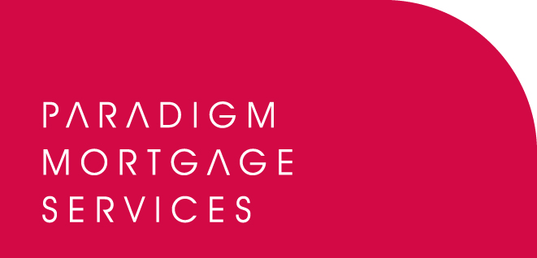

9 June 2010

PARADIGM GROUP INTRODUCE COMMERCIAL INSURANCE
OFFERING THROUGH TOWERGATE RISK SOLUTIONS

Paradigm Group, the support services business for IFAs and mortgage brokers which includes Paradigm Partners and Paradigm Mortgage Services, has today (9th June 2010) revealed a new commercial insurance offering to its members through Towergate Risk Solutions.

From today, Paradigm members will be able to refer clients to Towergate Risk Solutions in order to access one of the widest range of specialist and traditional commercial insurance products in the UK market. Towergate are also able to build bespoke policies for clients, whatever their business or interest.

Towergate Risk Solutions is Europe’s largest independently owned insurance intermediary – its leverage enables it to negotiate directly with insurers and underwriters on the design of high-quality products.

Bob Hunt, Partner at Paradigm Group and Chief Executive of Paradigm Mortgage Services, said:

“This new link-up with Towergate Risk Solutions offers a vast array of commercial insurance products to our members from one of the leading insurance businesses in the country. Paradigm Group members will now be able to make focused referrals to Towergate ensuring their clients benefit from their experience in the marketplace, their quality products and total flexibility in order to develop, where necessary, a bespoke insurance arrangement. Few companies offer this depth and breadth of service and we believe our member’s clients will be in safe hands with Towergate. We will work closely with the team at Towergate to ensure we offer a service which members will be keen to use and to ensure we help develop further income-generating opportunities for the growing number of advisers and brokers who are benefiting from their alliance with Paradigm Group.”

Darren Rowe, Managing Director of Towergate Risk Solutions in Leeds, commented:

“We are delighted that Towergate Risk Solutions has been chosen as the preferred commercial insurance supplier for Paradigm Group. We look forward to building a long-term relationship with Paradigm members and helping them to generate additional income streams from commercial insurance. We are confident we can offer an excellent service and would invite Paradigm members interested in working with us to visit the Paradigm website for full details of our offering.”

For more information please visit www.paradigmmortgages.com and click on the ‘GI’ tab.

For further information please contact:
Bob Hunt, Chief Executive, Paradigm Mortgage Services, Tel: 07767 462092
Karen Thomson, Head of Affinity & Network Sales, Towergate Risk Solutions Leeds & Halifax, Tel: 07770 975723
Rob Griffiths, White Dragon Communications Ltd, Tel: 01483 549282, Mobile: 07983 641566; rob@whitedragoncomms.co.uk

Notes to editors

About Paradigm Group
- Paradigm Partners and Paradigm Mortgage Services are limited liability partnerships. They offer those firms who sign up the opportunity for them to share in the capital growth of the businesses via discretionary trusts.
- Paradigm’s proposition delivers the following for its Partner members: a true partnership to enhance value for the intermediary firm in terms of both income and capital; a transparent model showing the additional revenue earned by each partner firm; a way to Treat Advisers Fairly; a way to bring Paradigm’s partners more of the value chain in investments, mortgages and pensions; a revolution in support services for intermediaries; provision of an exit strategy for the Partner; and a way to help the firm retain Registered individuals within the business.
- Paradigm Group offers Partner members access to: Paradigm Partnership, Paradigm Compliance Services, Paradigm Investment Management, Paradigm Wrap, and Paradigm Mortgage Services. All are supported by the Paradigm IT Support Suite.

Paradigm Partners LLP
Paradigm House
Brooke Court
Wilmslow
Cheshire
SK9 3ND
Tel: 0845 303 6333
Fax: 0845 303 8333

Paradigm Mortgage Services
Wellington House
Birmingham International Park
Solihull
West Midlands
B37 7HE
Tel: 0121-781 7337/7338
Fax: 0121-731 7339

