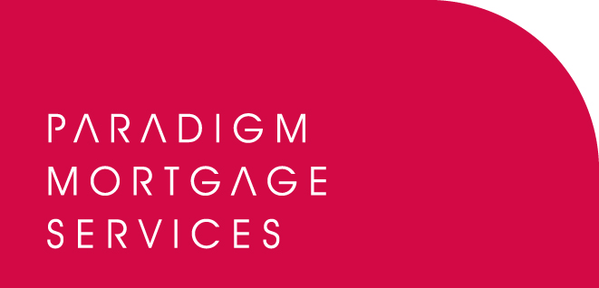

6 September 2011

PARADIGM LAUNCH REVAMPED WEBSITE

Paradigm Mortgage Services, the mortgage services proposition, has today (6th September 2011) launched its brand new website, www.paradigmmortgages.com with a host of new features and a streamlined, user-friendly feel.

Following feedback from its members, Paradigm has redesigned the layout and restructured the website sections in order for users to access all the necessary information far more easily and efficiently.

Key changes to the Paradigm website include:
- A cleaner design allowing easier navigation between pages based on a logical flow.
- New features such as lender underwriting guidelines, product information, downloadable forms, and contact information.
- Full procuration fee information is now displayed on individual lender pages instead of having to navigate away to a separate page.
- A specific news section including all Paradigm press releases, Chief Executive Bob Hunt’s blog and access to Paradigm’s regular member newsletter, Target.
- Members are also able to view and browse Paradigm’s services and products in a far easier format split into sectors such as GI, commercial loans, will-writing, specialist lending, compliance, life assurance, debt management, and savings and investments.

John Coffield, Head of Paradigm Mortgage Services, commented:

“As the scope and breadth of the services and products Paradigm offers has grown, so has our website. We recognised that some members found the old site slightly tricky to navigate because of the wealth of information and the number of pages we had built up. Having listened to feedback we decided to completely overhaul and revamp the site in order to make it far more user-friendly and to introduce a cleaner design which would facilitate this. By doing this we have also been able to structure the site in a far better way and we have introduced a number of new features which provide even greater detail and benefits to our members. We believe this new site allows users to access the information they want in a far more efficient fashion and we are urging all members to visit www.paradigmmortgages.com to try out the new site, and provide us with feedback on where they believe further improvements could be made. We want to deliver the most accessible site possible for Paradigm members and we will also be adding further features to it over the coming months.”

To view the new Paradigm Mortgage Services’ website, please visit: www.paradigmmortgages.com

ENDS

For further information please contact:
John Coffield, Head of Paradigm Mortgage Services, Mobile: 07825 613012
Rob Griffiths, White Dragon Communications Ltd, Mobile: 07983 641566; rob@whitedragoncomms.co.uk

Notes to editors

About Paradigm Mortgage Services
- Paradigm Mortgage Services offers IFAs and mortgage intermediaries the same opportunity. Members of the proposition benefit fully from market-leading procuration fees, have access to exclusive and semi-exclusive products, and share in the club’s ownership. Members will also have the added opportunity of building additional value wholly attributable to their own individual businesses. Paradigm Mortgage Services also offer a dedicated Mortgage Desk to members.
- Paradigm Mortgage Services is an associated business of Paradigm Partners LLP, the IFA support firm established by Paul Hogarth.
- Paradigm Partners is a limited liability partnership. It offers those firms who sign up the opportunity for them to share in the capital growth of the business via a discretionary trust.

Paradigm Partners LLP
Paradigm House
Brooke Court
Wilmslow
Cheshire
SK9 3ND
Tel: 0845 303 6333
Fax: 0845 303 8333

Paradigm Mortgage Services
Wellington House
Birmingham International Park
Solihull
West Midlands
B37 7HE
Tel: 0121-781 7337/7338
Fax: 0121-731 7339

