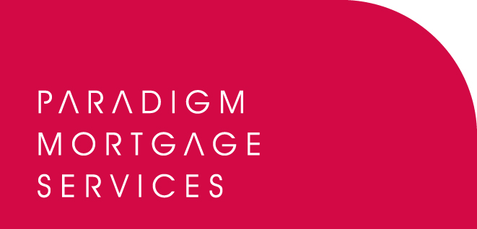

5 May 2010

PARADIGM GROUP ANNOUNCE PARTNERSHIP
WITH TOWERGATE HOME & PROTECT

Paradigm Group, the support services business for IFAs, mortgage brokers and its own ARs which includes Paradigm Partners, Paradigm Mortgage Services and Paradigm Financial Advisers, has today (5th May 2010) announced a new partnership with Towergate Home & Protect to provide members with access to its extensive home and buy-to-let insurance proposition.

From today Paradigm members will be able to provide their clients with Towergate’s wide range of web-based general insurance products. Home & Protect offer Buildings & Contents quotations from a panel which includes AXA, Equity Red Star, and Zurich plus a consortium of leading UK insurers.

In addition to competitive rates on standard home and buy-to-let insurance, Towergate Home & Protect also offer specialist support for cases that are difficult to place. Specialist insurance products include cover for buy-to-let property portfolios, high net worth schemes, unoccupied thatched, or previously underpinned properties, homes of non-standard construction and holiday homes.

Towergate Home & Protect has also recently relaunched its Mortgage Payment Protection and Income Protection products with a choice of Accident Sickness and Unemployment, Accident and Sickness only or Unemployment cover.

David Ford, Managing Director of Towergate Home and Protect, commented:

“Home and Protect brings to the market a unique proposition based on ease, choice and value. We have established a common policy wording for our household building and contents panel; a non-standard solution for more difficult to place risks and a wide range of web-based general insurance products to make placing business easier for Paradigm Group members.

“We’re part of the Towergate Partnership, Europe’s largest independently-owned insurance intermediary. Over the last 12 months we have established excellent working relationships with a number of leading distributors providing access to over 8,000 agents, with plans to broaden our distribution even further. We are confident that we can offer the registered individuals of Paradigm’s 600-plus firms with an excellent service and invite Paradigm members interested in working with us to visit the Paradigm website to register their interest.”

Bob Hunt, Partner at Paradigm Group and Chief Executive of Paradigm Mortgage Services, said:

“At Paradigm Group we are always looking for ways to add value to the services we offer our members which is why we seek to establish a broad range of partnerships in a wide variety of sectors. The strong proposition offered by Towergate Home & Protect and the range of highly competitive GI products seemed an obvious addition to make to our own GI offering. It is always our aim to offer Paradigm members the most attractive and competitive terms available in the market and we believe this is the case with Towergate Home & Protect. I would urge all Paradigm members to visit our websites to gain full information on this exciting new relationship and we look forward to working with the Home & Protect team in the future.”

For more information please visit www.paradigmmortgages.com and click on the ‘General Insurance (GI)’ tab.

For further information please contact:
Bob Hunt, Chief Executive, Paradigm Mortgage Services, Tel: 07767 462092
Jennifer Wilson, Marketing Manager, Towergate Home & Protect, Tel: 01704 518660
Rob Griffiths, White Dragon Communications Ltd, Tel: 01483 549282, Mobile: 07983 641566; rob@whitedragoncomms.co.uk

Notes to editors

About Paradigm Group
- Paradigm Partners and Paradigm Mortgage Services are limited liability partnerships. They offer those firms who sign up the opportunity for them to share in the capital growth of the businesses via discretionary trusts.
- Paradigm’s proposition delivers the following for its Partner members: a true partnership to enhance value for the intermediary firm in terms of both income and capital; a transparent model showing the additional revenue earned by each partner firm; a way to Treat Advisers Fairly; a way to bring Paradigm’s partners more of the value chain in investments, mortgages and pensions; a revolution in support services for intermediaries; provision of an exit strategy for the Partner; and a way to help the firm retain Registered individuals within the business.
- Paradigm Group offers Partner members access to: Paradigm Partnership, Paradigm Compliance Services, Paradigm Investment Management, Paradigm Wrap, and Paradigm Mortgage Services. All are supported by the Paradigm IT Support Suite.

Paradigm Partners LLP
Paradigm House
Brooke Court
Wilmslow
Cheshire
SK9 3ND
Tel: 0845 303 6333
Fax: 0845 303 8333

Paradigm Mortgage Services
Wellington House
Birmingham International Park
Solihull
West Midlands
B37 7HE
Tel: 0121-781 7337/7338
Fax: 0121-731 7339

