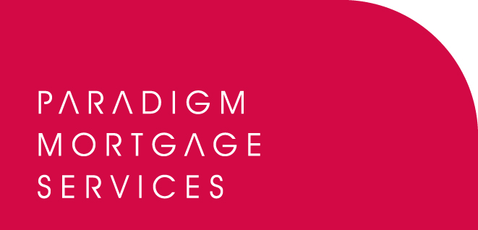

27 June 2011

PARADIGM PARTNER WITH CA TAX SOLUTIONS

Paradigm Group, the IFA and mortgage partnership proposition, has today (27th June 2011) announced a new partnership with CA Tax Solutions to help advisers deliver to their commercial property clients the maximum capital allowance tax savings and benefits.

CA Tax Solutions specialises in identifying retrospective capital allowance benefit on behalf of commercial property owners (individuals, LLPs, Ltd Company’s) with portfolios ranging from £400k to £150m.

UK commercial property owners are entitled to a form of tax relief called Capital Allowances. However CA Tax Solutions believes over 96% of UK commercial property owners have not identified or claimed their full entitlement of capital allowance tax savings with many having not claimed at all. The HMRC recently published a consultation document, ‘Capital Allowances for Fixtures’ which includes proposals, if passed into law, would mean the removal of retrospective tax rebates for owners on fixtures within buildings.

CA Tax Solutions can work with advisers’ commercial property owner clients to review their capital allowance position and to make sure they do not lose out on a potentially significant tax rebate.

This new partnership with CA Tax Solutions can provide a number of benefits for both clients and advisers including:
- The operation of a 100% ‘no claim, no fee’ policy to ensure all parties receive the expected benefits and returns.
- If CA Tax Solutions fail to identify £50k of additional allowances, or the client’s accountant does not sign off on its report, it will not charge for the work.
- 20% of CA Tax Solutions’ fee will be paid to introducing Paradigm member firms.

Paradigm Group includes Paradigm Mortgage Services, Paradigm Partners and Paradigm Financial Advisers.

Bob Hunt, Chief Executive of Paradigm Mortgage Services, commented:

“The area of capital allowances for commercial property owners may not be one many advisers are familiar with however there are clearly many tax savings and benefits that are being missed at present. Also, with potential new regulation on the horizon now is the time for advisers to ensure their client is receiving their full entitlement. By partnering with a specialist, such as CA Tax Solutions, advisers can be certain that their client’s interests are being looked after and they could be the source of a significant refund for them. Quarter on quarter, CA Tax Solutions secure significant tax refunds paid direct to clients, therefore there are a number of strong reasons to ascertain their current position. We believe we are working with a true specialist in their field and would urge any Paradigm member who may have clients who this is relevant for to visit our website for more details.”

David Oliver, Director at CA Tax Solutions, said:

“We are delighted to be partnering with the Paradigm Group and see the relationship delivering significant savings and benefits across its client base. Paradigm recognises the importance of keeping its members fully informed with regard to any changes to legislation or the introduction of products and service that will enhance their clients’ financial position. With the potential changes to an already complex and under-utilised peice of tax legislation, Paradigm and CA Tax Solutions have come together to ensure all of their members associated with commercial property owners have the facility to establish the capital allowance history of their buildings. By working with Paradigm Group’s members, we can ensure all their client’s available capital allowances are identified and generate the maximum return and benefit. To find out more, Paradigm members should simply call our office quoting ‘Paradigm’.”

For full details on Paradigm’s partnership with CA Tax Solutions, please visit: www.paradigmmortgages.com/catax.html

For more information on CA Tax Solutions, please visit: www.cataxsolutions.com

ENDS

For further information please contact:
Bob Hunt, Chief Executive of Paradigm Mortgage Services, Mobile: 07767 462092
David Oliver, Director of CA Tax Solutions, Mobile: 07825 547676
Rob Griffiths, White Dragon Communications Ltd, Tel: 01483 549282, Mobile: 07983 641566; rob@whitedragoncomms.co.uk

Notes to editors

About Paradigm Mortgage Services
- Paradigm Mortgage Services offers IFAs and mortgage intermediaries the same opportunity. Members of the proposition benefit fully from market-leading procuration fees, have access to exclusive and semi-exclusive products, and share in the club’s ownership. Members will also have the added opportunity of building additional value wholly attributable to their own individual businesses. Paradigm Mortgage Services also offer a dedicated Mortgage Desk to members.
- Paradigm Mortgage Services is an associated business of Paradigm Partners LLP, the IFA support firm established by Paul Hogarth.
- Paradigm Partners is a limited liability partnership. It offers those firms who sign up the opportunity for them to share in the capital growth of the business via a discretionary trust.

Paradigm Partners LLP
Paradigm House
Brooke Court
Wilmslow
Cheshire
SK9 3ND
Tel: 0845 303 6333
Fax: 0845 303 8333

Paradigm Mortgage Services
Wellington House
Birmingham International Park
Solihull
West Midlands
B37 7HE
Tel: 0121-781 7337/7338
Fax: 0121-731 7339

