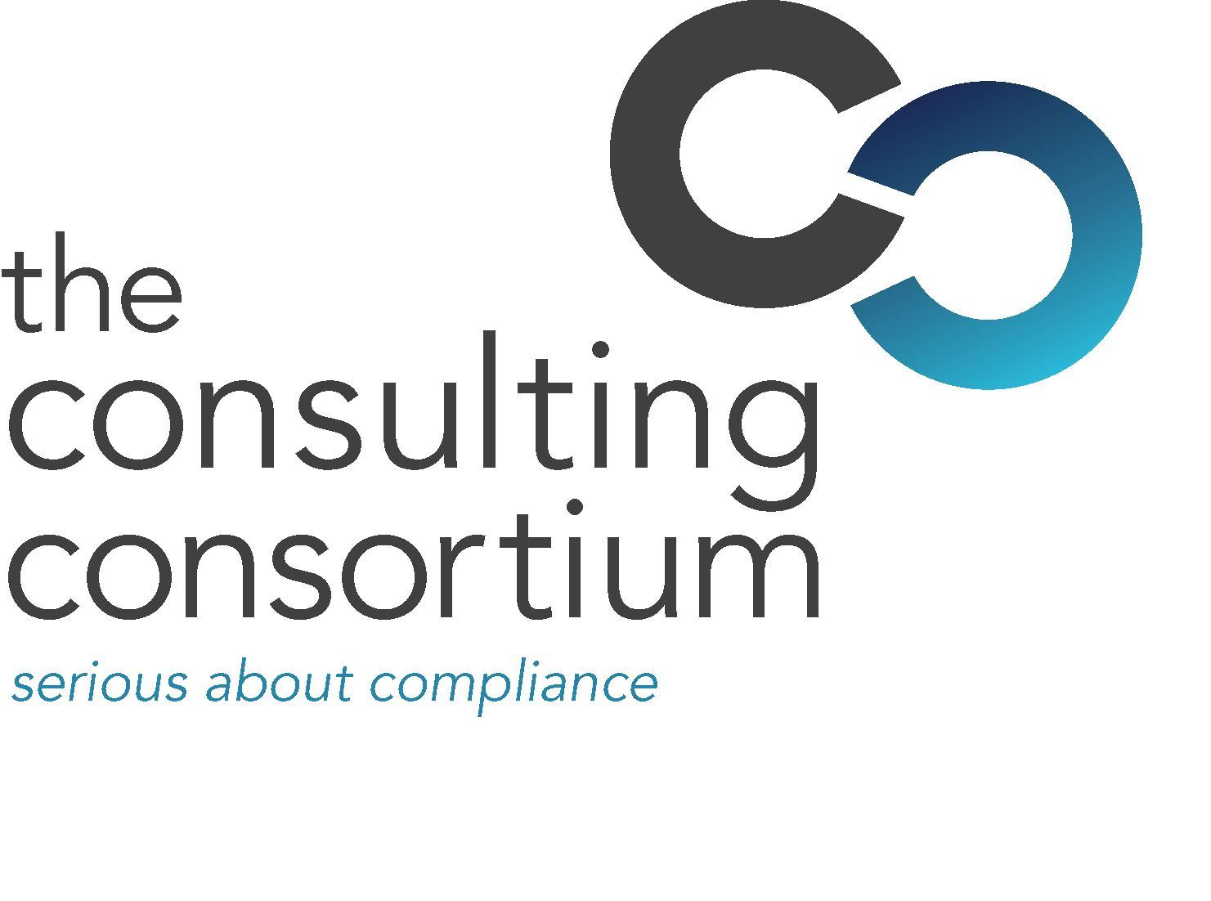

10 MAY 2009

TCC and Intellego join forces to tackle RDR challenges

The Consulting Consortium (TCC) has joined forces with learning specialist Intellego to form a partnership to ensure firms will have access to all the relevant training and compliance tools to tackle the continuing RDR challenges.
The two firms have formed an alliance to combat current uncertainty revolving around RDR. Their goal is to use their combined capabilities and experience to create innovative training solutions to help firms operating in the financial services sector get to grips with all their training and compliance requirements, in response to one of the most fundamental changes experienced across the industry.
Firms can expect more intensive supervision in the run-up to the implementation of the RDR in 2012 through mystery shoppers and analysis of charges as well as product use. Training and all aspects of compliance procedures will be closely monitored during the transitional period to the new rules, while the whole process will be reviewed after introduction
TCC believes that the combination of specialist knowledge, expertise and technological solutions brought together by this alliance will enable it to offer a greater range of RDR specific solutions than any other compliance specialist.
TCC has been providing expert support and guidance in the realm of FSA compliance for over 10 years. Intellego’s capacity to tailor innovative e-learning based solutions that heighten performance, compliance and improve financial return ensures firms can access suitable training tools that enable the learner to develop new skills and capabilities in a way that meets a variety of learning styles.
Jill Wade, Director of Learning Solutions at The Consulting Consortium, said:
“We genuinely believe that this alliance with Intellego enables us to offer a vast array of state of the art RDR solutions for firms of all sizes and budgets that are unparalleled in the current marketplace. There is no getting away from the fact that the RDR is a complex area and with cost continuing to mount it is essential that firms look for cost effective but highly engaging training and compliance programmes. There is no one-size-fits all solution to firms RDR requirements and it is vital that firms address professional development within their organisations. The current trend of more proactive supervision of the industry as experienced of late means that firms must get their compliance procedures right first time or feel the wrath of the regulator.”
John Hammond, Sales and Marketing Director at Intellego Group Ltd, said:
“We are delighted to be working with such a well regarded industry expert as TCC. We hope to develop our existing capabilities through the acquisition of the Professional Development Partnership and in combination with TCC to extend our offerings in addressing this major challenge for the industry. We do not believe that there is a single response to the RDR requirement but that a variety of different innovative approaches will enable customers to have a choice in how they support their staff going forward. By merging together industry knowledge, a strong understanding of learning and technology we believe this partnership will provide effective and appropriate solutions to this market”
For full information on The Consulting Consortium, firms should visit: www.theconsultingconsortium.com

ENDS

For further information please contact:
Joanne Smith, managing director at The Consulting Consortium; Tel: 0207 645 8808; Mobile 07775 623134; Email: jsmith@theconsultingconsortium.com
Scott Philipson, White Dragon Communications Ltd, Mobile: 07786 226520; Email: scott@whitedragoncomms.co.uk

Notes to editors
Founded in 2000, The Consulting Consortium (TCC) is a regulatory consultancy which provides advice and guidance on activities regulated by the Financial Services Authority and, in particular, the application of the FSA's regime on financial services products.
With offices in London and Yorkshire, The Consulting Consortium's consultants offer innovative, fully FSA compliant and long term solutions to client's individual regulatory scenarios. The Consulting Consortium's sister company, TCC Recruit, specialises in recruiting staff for regulatory compliance, risk and corporate governance positions.
The Consulting Consortium is quality conscious at all times and offers clients a quality of service which is unsurpassed in the regulatory industry.
The consultant database is hand picked and managed by The Consulting Consortium’s own full time resource. This allows The Consulting Consortium to be highly responsive to clients needs whilst offering exceptional service and value for money.
The Consulting Consortium's sister company, TCC Recruit, specialises in recruiting staff for regulatory compliance, risk and corporate governance positions.

About Intellego
Listed on the Alternative Investment Market (AIM) in London, Intellego is a publisher and developer of creative and innovative elearning-based solutions that heighten performance, ensure compliance and improve financial return.
With extensive experience and a deep understanding of the challenges faced by the Retail, Financial Services & Pharmaceutical Life Science industries, we have a loyal client base of over 250 loyal customers who are located globally, including AstraZeneca, Schering-Plough, Sanofi-Aventis, Boots, B&Q, and Specsavers who continue to benefit from our integrated "courseware with infrastructure" model of e-learning solutions provision.
The Consulting Consortium (TCC)
107 Cannon Street
London
EC4N 5AF
Telephone: 020 7645 8808

