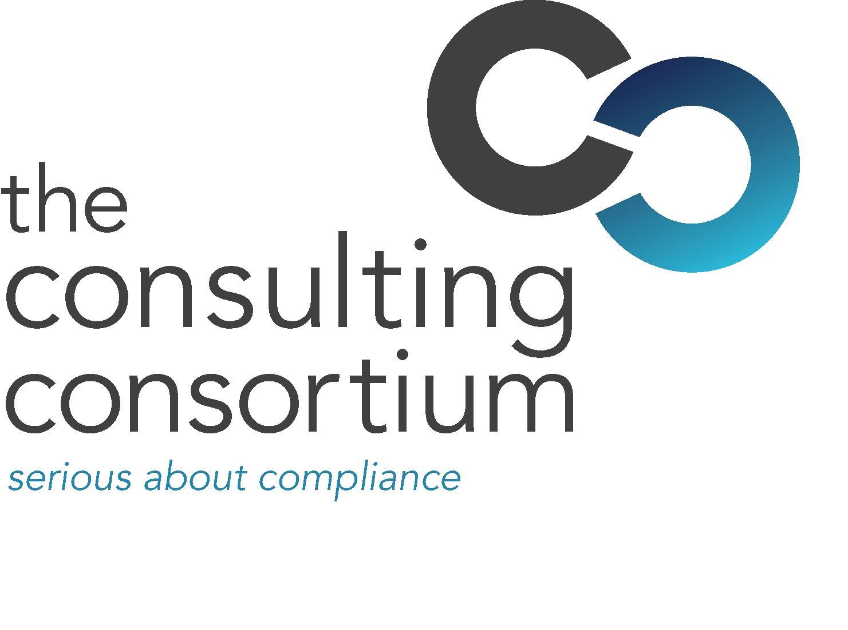

3 June 2009

The Consulting Consortium appoints BDM

The Consulting Consortium (TCC) has added to its team of notable industry professionals by recruiting Sandro Buttaci to its Customer Engagement Team.

Sandro has worked for two leading online information providers in the regulatory market place and brings over 10 years market knowledge and contacts to the position of Business Development Manager. His previous roles incorporated the sales and marketing of risk and compliance software solutions and subscription services to the global financial services industry.

Sandro will initially be tasked with showcasing The Consulting Consortium's Risk Frameworker, a unique risk self-assessment tool which enables firms to demonstrate that they have the correct system and controls in place for any FSA visit. In addition he will also be offering the full suite of The Consulting Consortium’s products and services, ranging from consulting, outsourcing and resourcing to its Serious Learning proposition.

Joanne Smith, Managing Director at The Consulting Consortium, said:

“Sandro brings terrific insight into financial services products and their relevance to businesses and will complement the existing strong customer focussed team at The Consulting Consortium. He is known for opening new markets, launching products and developing customised product solutions, and we look forward to Sandro’s sales and marketing experience in building solid value propositions for our client base.”

For full information on The Consulting Consortium, firms should visit: www.theconsultingconsortium.com

ENDS

For further information please contact:
Joanne Smith, managing director at The Consulting Consortium; Tel: 0207 645 8808; Mobile 07775 623134; Email: jsmith@theconsultingconsortium.com
Scott Philipson, White Dragon Communications Ltd, Mobile: 07786 226520; Email: scott@whitedragoncomms.co.uk

Notes to editors
Founded in 2000, The Consulting Consortium (TCC) is a regulatory consultancy which provides advice and guidance on activities regulated by the Financial Services Authority and, in particular, the application of the FSA's regime on financial services products.
With offices in London and Yorkshire, The Consulting Consortium's consultants offer innovative, fully FSA compliant and long term solutions to client's individual regulatory scenarios. The Consulting Consortium's sister company, TCC Recruit, specialises in recruiting staff for regulatory compliance, risk and corporate governance positions.
The Consulting Consortium is quality conscious at all times and offers clients a quality of service which is unsurpassed in the regulatory industry.
The consultant database is hand picked and managed by The Consulting Consortium’s own full time resource. This allows The Consulting Consortium to be highly responsive to clients needs whilst offering exceptional service and value for money.
The Consulting Consortium's sister company, TCC Recruit, specialises in recruiting staff for regulatory compliance, risk and corporate governance positions.
The Consulting Consortium (TCC)
107 Cannon Street
London
EC4N 5AF
Telephone: 020 7645 8808

