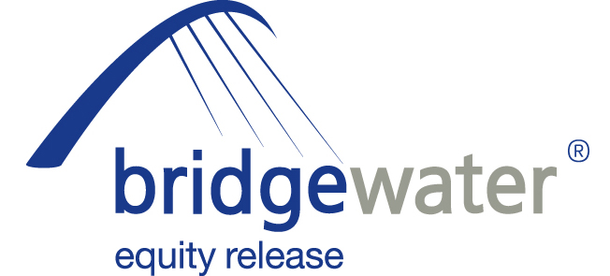

10 February 2012

BRIDGEWATER LAUNCH SERIES OF
‘JUST A THOUGHT...’ SALES AIDS

Bridgewater Equity Release, the home reversion specialists, has today (10th February 2012) launched a series of sales aids for advisers entitled, ‘Just a thought...’

The ‘Just a thought...’ series of aids are designed to provide advisers with information on situations where equity release may be a credible solution to a client’s needs. The first three cover the following areas:
- ‘Using equity release to finance divorce.’
- ‘Using equity release to repay a mortgage.’
- ‘Using equity release to fund a house purchase.’

Each aid provides background information, statistics and a relevant client case study on the situation to help non-specialist advisers see opportunities for using equity release with their clients.

Bridgewater hope the aids will also be used by specialist advisers with their introducer contacts in order to help them explore the potential equity release angle and to ensure they do not overlook the potential opportunity for clients who may have little or no knowledge of the products.

All Bridgewater sales aids can be downloaded from the adviser resource centre on its website.

Peter Welch, Head of Sales and Distribution at Bridgewater Equity Release, commented:

“These ‘Just a thought...’ sales aids are essentially adviser aide memoires - quick bites of information covering a variety of client situations where an equity release product solution may be appropriate. The first three cover divorce, repaying a mortgage and funding a purchase – all areas where equity release could provide the answer to a client’s particular needs. Advisers can also hand out these aids to their introducers to help quickly outline why equity release might be appropriate for their clients, plus they include case study information from Bridgewater clients who have achieved their particular aims with an equity release product. The adviser also has space to include their own contact details so they can also provide a marketing function to generate referrals of new leads.

“At Bridgewater we are always looking at how we can provide advisers with extra resources in order to help them broaden the reach of equity release. In particular, these one-page ‘Just a thought...’ documents should help introducers recognise that equity release can help their clients in a variety of situations, particularly those where it has traditionally been overlooked or ignored. These are the first in the ‘Just a thought...’ range but they will not be the last; we intend to issue more throughout the year and would welcome adviser feedback on other areas where such an aid may prove useful.”

To download the ‘Just a thought...’ sales aids please visit: http://www.bridgewaterequityrelease.co.uk/advisers/resources/

ENDS

For further information please contact:
Peter Welch, Head of Sales and Distribution, Bridgewater Equity Release, Mobile: 07824 412439
Kurt Mueller, External Affairs Manager, Grainger plc (parent company of Bridgewater Equity Release), Mobile: 07584 235088; kmueller@graingerplc.co.uk
Rob Griffiths, White Dragon Communications Ltd, Mobile: 07983 641566; rob@whitedragoncomms.co.uk
Barney McCarthy, White Dragon Communications, Mobile: 07872 956711; barney@whitedragoncomms.co.uk

Notes to editors

- Bridgewater Equity Release Limited was founded in 1998 and is the UK’s leading provider of home reversion plans with over 4,000 home reversion customers.
- Bridgewater Equity Release Limited is an award-winning provider and a member of Safe Home Income Plans (SHIP), the company dedicated to the protection of plan holders and the promotion of safe home income and equity release plans. Bridgewater offers a range of plans which abide by the SHIP Code of Practice.
- It is committed to ensuring that all its customers are fully aware of the scheme they are entering into and have considered all alternatives.
- Bridgewater Equity Release is a subsidiary of Grainger plc, which was established in 1912.
- Bridgewater Equity Release is a registered trade mark of Grainger plc. All rights reserved.
- Grainger plc is the UK’s largest specialist residential property owner and manager traded on the London Stock Exchange. Grainger’s business activities in the UK and Germany cover ownership, trading, fund management, property management and development of residential property. Grainger is the leading provider of home reversions, an equity release product, through Bridgewater Equity Release. Grainger has approximately £2.1 billion of wholly-owned property assets, £2.8 billion of assets under management and manages approximately 26,400 properties in the UK and Germany.

Bridgewater Equity Release Ltd
Citygate, St James’ Boulevard
Newcastle upon Tyne
Tyne and Wear
NE1 4JE
Tel: 0191-242 4820
Fax: 0191-269 5974
E-mail: enquiries@bridgewaterequityrelease.co.uk

