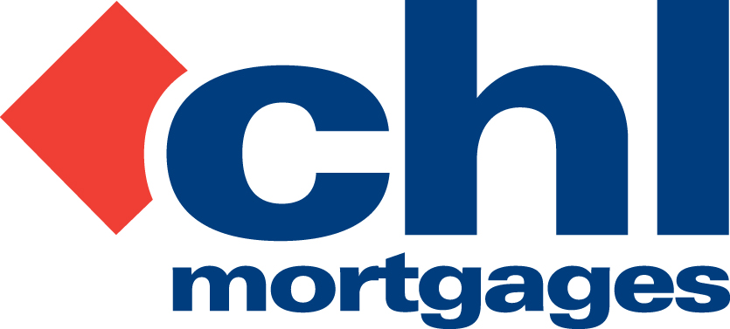

4 JULY 2011

PRESS RELEASE

‘LANDLORDS POSITIVE ABOUT FUTURE OF
BUY-TO-LET’, SAYS CHL RESEARCH

Specialist lender, CHL Mortgages, has today (4th July 2011) announced the results of its annual Landlord Survey and revealed growing positivity from sector participants about the outlook for buy-to-let.

67% of respondents said they were positive about the future of buy-to-let; this is up slightly on twelve months ago when the result was 64%.

Landlords were particularly positive about rental demand with 43% suggesting it is now better than six months ago and it is sufficient to cover mortgage repayments, maintenance and cost - up from 35% last year.

CHL believe this supports the view that rental yields for residential investment properties have accelerated since the Credit Crunch and subsequent recession three years ago.

In terms of short-term plans, 33% of landlords said they were looking to buy more investment properties in the next 12 months – up from 28% last year - however a lack of finance was still cited as the biggest constraint to achieving this aim. The other major constraint on expansion was the high deposit requirements (28%) that now come with buy-to-let mortgage products.

Other survey highlights include:
- One in five respondents said they would consider fixing their buy-to-let mortgage to protect them against future interest rises.
- Four in five landlords make adequate provisions for maintenance of their investment properties from rent receipts.
- The same figure indicated they do not make overpayments on their borrowings indicating that borrowers are more inclined to channel any surplus rental income towards maintenance.

CHL believe the growing positivity shown by its landlord borrowers is reflected in its own arrears experience. At the end of May this year, the number of accounts greater than three months in arrears had fallen to 855 from a 2010 year-end figure of 933. This represents just 1.92% of CHL’s total of 44,477 live accounts on its loan book and the lender fully expects this downward trend to continue despite a still uncertain economic outlook.

Bob Young, Managing Director at CHL Mortgages, commented

“Our 2011 Landlord Survey confirms that buy-to-let remains an attractive asset class for savvy investors. Landlords are clearly positive about the future of buy-to-let and they have good reason to feel this way with rental demand growing as a result of a number of underlying drivers. Clearly, a lack of credit, tougher lending criteria and higher deposit requirements are suppressing residential property ownership for many, which is resulting in considerable pent-up rental demand – a real positive for the private rental sector.

“With uncertainty in the equity and bond markets we can therefore expect more investors to reconsider buy-to-let as an alternative asset class; even more so if property prices continue to fall over the next couple of years. We can also expect some accidental landlords or investors who unfortunately ‘bought the brochure’ pre-Credit Crunch to exit the market if an opportunity presents itself, and existing landlords who are committed to the sector and eyeing up further purchases may well be able to enhance their portfolios as this happens.”

For full information on CHL visit: www.chlmortgages.co.uk

ENDS

For further information please contact:
Bob Young, Managing Director, CHL Mortgages
Tel: 01252 365890
Rob Griffiths, White Dragon Communications Ltd
Mobile: 07983 641566, Office Direct Dial: 01483 549282; rob@whitedragoncomms.co.uk

NOTES TO EDITORS

- CHL Mortgages has been offering specialist mortgage solutions since 1992. It is based in Fleet, Hampshire and is part of the Irish Life & Permanent Group.
- CHL Mortgages is a pioneer of both buy-to-let mortgages and self-certification mortgage products for the self-employed. It has now grown to be a leading player in these sectors.
- CHL products are designed to meet the needs of various customers, ensuring CHL Mortgages lends responsibly and treats customers fairly.

CHL Mortgages
Admiral House, Harlington Way, Fleet, Hampshire GU51 4YA
Tel: 01252 812271
Fax: 01252 811826
Website: www.chlmortgages.co.uk

