Association of Bridging Professionals (AOBP)
Press Release
For immediate release on Wednesday, February 8th 2012
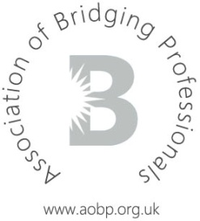

Association announces details of first ever AOBP Quarterly Forum
The Association of Bridging Professionals is proud to announce the details of 2012’s March Quarterly Event which will be the first of its kind, taking place at The Electric Cinema in Notting Hill on Thursday, March 8th 2012 from 10am.

Silver, Affiliate and Lender Associates are invited to attend the event at which a panel will face a select group of Blue Associate intermediaries and answer their burning questions relating to bridging and commercial finance.

The panel will consist of three Executive Committee members, three Affiliates and five Lenders. Up to 60 brokers will have the unique opportunity to put their questions and comments to the panel in the form of a Q&A-style discussion. In addition, the Executive Committee will have prepared a selection of topics for consideration.

The Affiliate complement will provide insight from a professional service provider’s point of view and attendees can expect to hear from valuers, solicitors and compliance experts.

Breakfast and refreshments will be served from 10am for an hour after which the Forum will begin.

Places for Blue Associates are limited to sixty, therefore members are encouraged to register promptly. Should members not be able to attend on this occasion, you will be accommodated at one of the Quarterly Events in June/July and September/October.

Members may register by emailing the AOBP secretary via info@aobp.org.uk and non-members who would like further information or are interested in joining may call 0207 316 1838 or email as above.

-ends-

Notes for editors:
For press enquiries, please contact Craig Scott, Press Officer on 0845 271 2690
About the Association of Bridging Professionals (AOBP):
For further information about the AOBP please visit www.aobp.org.uk
The AOBP provides a service to intermediaries, master brokers and packagers in the Bridging industry by providing a forum for discussion on non-competitive issues, acting as a trade body to
Association of Bridging Professionals (AOBP)
Press Release
For immediate release on Wednesday, February 8th 2011

help promote a favourable operating environment and providing information to assist them in their business.
The AOBP is a not for profit company limited by guarantee and is registered in England number 07372027

