Association of Bridging Professionals (AOBP)
Press Release
October 11 2011
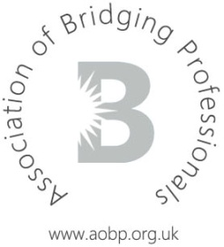

Lowry Capital joins AOBP Affiliate Lender panel
The Association of Bridging Professionals (AOBP) continues to grow and is delighted to announce its latest Affiliate Lender to the panel – Lowry Capital.
Lowry Capital is an award-winning principal short term lender which prides itself on high LTVs, true nationwide lending and speedy turnaround times.
Newly appointed Executive Committee member and Director of specialist packager Only Bridging, Simon Juniper, is responsible for recruiting this latest lender member.
Jonathan Caplan, Director at Lowry Capital, commented: “I have watched the AOBP grow into a large and respected organisation and we have worked successfully with many of the executive and associates. I was delighted to be invited by Simon Juniper to join as we have had a long working relationship with Only Bridging. We look forward to playing a full part in the organisation as it grows and continues to take a prominent role on behalf of its members.”
On behalf of the Executive Committee, Press Officer and Director of Commercial 1, said: “Lowry Capital has a well-established reputation in the bridging market, which has been built on giving an excellent service to both individuals and companies. The AOBP welcomes Lowry as a valuable addition to its affiliate panel.”
The number of affiliate lenders is up to 15, following the recent joining of Alternative Bridging Corporation (ABC) and Omni Capital.
-ends-

Association of Bridging Professionals (AOBP)
Press Release
October 11 2011

Notes for editors:
For press enquiries, please contact Craig Scott, Press Officer on 0845 271 2690
About the Association of Bridging Professionals (AOBP):
For further information about the AOBP please visit www.aobp.org.uk
The AOBP provides a service to intermediaries, master brokers and packagers in the Bridging industry by providing a forum for discussion on non-competitive issues, acting as a trade body to help promote a favourable operating environment and providing information to assist them in their business.
The AOBP is a not for profit company limited by guarantee and is registered in England number 07372027

