Association of Bridging Professionals (AOBP)
Press Release
August 16th 2011
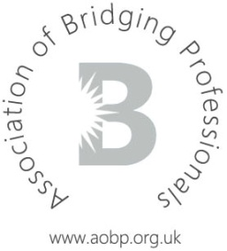

AOBP Annual General Meeting announced
The Association of Bridging Professionals (AOBP) is fast-approaching its 1st birthday in September and will be celebrating this at the Annual General Meeting, to which all members of all tiers are invited.
As we are well aware of how busy social calendars can get, this is the official Save the Date for the event which is to be held on Thursday, October 6th 2011 at a Central London venue.
It will commence at 10am with breakfast and refreshments, followed by presentations by our Executive Committee members, prominent industry figures and select Affiliate lenders, amongst others. This is the perfect occasion for intermediaries to meet like-minded professionals and gain insight into the future of bridging finance and its multitude of opportunities.
This is going to be a fantastic occasion, documenting one year in the life of the AOBP: its astounding growth, continued membership support, progress as a representative body and active participation in promoting the bridging sector.
It will be an absolute pleasure to see all members there on the day and full details will be provided in the next two weeks.
All questions relating to the event, including access to limited press invitations, as well as membership applications, may be directed to AOBP Secretary, Tina Patel, info@aobp.org.uk.
All press and media enquiries should be directed to Press Officer, Craig Scott, cscott@commercial1.co.uk.
-ends-

Association of Bridging Professionals (AOBP)
Press Release
August 16th 2011

Notes for editors:
About the Association of Bridging Professionals (AOBP):
For further information about the AOBP please visit www.aobp.org.uk
The AOBP provides a service to intermediaries, master brokers and packagers in the Bridging industry by providing a forum for discussion on non-competitive issues, acting as a trade body to help promote a favourable operating environment and providing information to assist them in their business.
The AOBP is a not for profit company limited by guarantee and is registered in England number 07372027

