**Association of Bridging Professionals (AOBP)**

**Press Release**

**October 24 2011**

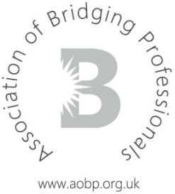

**Short term development loan provider becomes 16th Affiliate Lender**

Goldentree Financial Services has become the latest member to join the Association of Bridging Professionals (AOBP) as an Affiliate Lender.

Goldentree specialises in development bridging and are known for their flexible attitude, willingness to lend on quirkier properties and ability to tackle of the more ‘difficult’ deals. The company is financially backed by Fred Done, owner of leading bookmakers Betfred.

Managing Director, Steve Marsh, said: "Goldentree are delighted to have joined the AOBP and look forward to contributing to the organisation’s development.

“Goldentree are one of the few development funders currently operating in the UK and, backed by substantial private funds, can provide very flexible and imaginative solutions to all short term property lending situations. We look forward to utilising the AOBP broker base to distribute our products."

Press officer for the AOBP and director of specialist distributor Commercial 1, commented: “The AOBP welcomes the addition of Goldentree Financial Services to the affiliate panel. We are excited to have our first development specialist on board and with their substantial financial support as principal lenders, we trust that their inclusion in the AOPB will prove beneficial to our membership base.”

Goldentree are also members of the Association of Short Term Lenders (astl) and the National Association of Commercial Finance Brokers (NACFB).

**-ends-**

**Association of Bridging Professionals (AOBP)**

**Press Release**

**October 24 2011**



**Notes for editors:**

**For press enquiries, please contact Craig Scott, Press Officer on 0845 271 2690**

About the Association of Bridging Professionals (AOBP):

For further information about the AOBP please visit [www.aobp.org.uk](http://www.aobp.org.uk)

The AOBP provides a service to intermediaries, master brokers and packagers in the Bridging industry by providing a forum for discussion on non-competitive issues, acting as a trade body to help promote a favourable operating environment and providing information to assist them in their business.

The AOBP is a not for profit company limited by guarantee and is registered in England number 07372027